Comprehensive Analysis of Flight Delay Prediction Experiments: Destination Weather Impact Study
Table des matières
Comprehensive Analysis of Flight Delay Prediction Experiments: Destination Weather Impact Study 1
1. Executive Summary 4
1.1 Experimental Scope and Objectives 4
1.2 Data Sources and Files Analyzed 5
1.3 Structure of the Report 5
1.4 Analytical Strategy 5
1.5 Summary 6
2. Local-D2-60-0-x Experience Set 6
2.1 Global Synthesis of Experimental Results 7
2.2 Detailed Analysis of the Destination Weather Experiment Family (Experience-local-D2-60-0-X) 8
2.2.1 Methodology and Controlled Variables 8
2.2.2 Predictive Performance Analysis 9
2.2.3 Cross-Validation Stability Analysis 10
2.2.4 Runtime and Computational Cost Analysis 11
2.3 Feature Importance Deep Analysis 11
2.3.1 Baseline Feature Profile: Experience-local-D2-60-0-0 11
2.3.2 The Shift in Feature Dominance with Weather Integration 12
2.3.3 Aggregate Importance of Weather Features 12
3. Local-D2-60-X-0 Experience Set 13
3.1 Global Synthesis of Experimental Results 14
3.2 Detailed Analysis of the Origin Weather Experiment Family (Experience-local-D2-60-X-0) 15
3.2.1 Methodology and Controlled Variables 15
3.2.2 Predictive Performance Analysis 15
3.2.3 Cross-Validation Stability Analysis 17
3.2.4 Runtime and Computational Cost Analysis 18
3.3 Feature Importance Deep Analysis 18
3.3.1 Baseline Feature Profile: Experience-local-D2-60-0-0 18
3.3.2 The Shift in Feature Dominance with Weather Integration 19
3.3.3 Aggregate Importance of Weather Features 20
3.4 Comparative Analysis: Origin vs. Destination Weather Impact 20
3.4.1 Head-to-Head Performance Comparison 20
3.4.2 Feature Dominance and Predictive Power 21
3.4.3 Cost-Benefit Analysis 21
3.4.4 Strategic Conclusion 21
4. Local-D2-60-X-X Experience Set: Symmetric Weather Integration Analysis 22
4.1 Global Synthesis of Experimental Results 22
4.2 Detailed Analysis of the Symmetric Weather Experiment Family (Experience-local-D2-60-X-X) 23
4.3 Feature Importance Deep Analysis 26
4.4 Comparative Analysis: Symmetric vs. Single-Source Weather Impact 29
5. Optimized-Local-D2-60-X-X Model Capacity Study 30
5.1 Global Synthesis of Experimental Results 30
5.2 Detailed Analysis of the Optimized Model Family 32
5.2.1 Methodology and Controlled Variables 32
5.2.2 Predictive Performance Analysis 32
5.2.3 Cross-Validation Stability Analysis 35
5.2.4 Runtime and Computational Cost Analysis 35
5.3 Feature Importance Deep Analysis 35
5.4 Comparative Analysis: Optimized vs. Standard Symmetric Models 36
5.4.1 Head-to-Head Performance Comparison 36
5.4.2 Cost-Benefit Analysis 38
5.4.3 Strategic Conclusion 38
6. Lamsade-D2-60-X-X Experience Set: Symmetric Weather Integration on the Lamsade Cluster 38
6.1 Global Synthesis of Experimental Results 39
6.2 Detailed Analysis of the Symmetric Weather Experiment Family 39
6.2.1 Methodology and Controlled Variables 39
6.2.2 Predictive Performance Analysis 40
6.2.3 Cross-Validation Stability Analysis 40
6.2.4 Runtime and Computational Cost Analysis 41
6.3 Feature Importance Deep Analysis 42
6.4 Comparative Analysis: Lamsade Cluster vs. Local Environment 42
6.5 Strategic Conclusion 43
7. Lamsade-Dx-7_7 Dataset Comparison: Performance Analysis on the Lamsade Cluster 43
7.1 Global Synthesis of Experimental Results 43
7.2 Detailed Performance and Cost Analysis 44
7.2.1 Methodology and Controlled Variables 44
7.2.2 Predictive Performance Analysis 44
7.2.3 Cross-Validation Stability Analysis 45
7.2.4 Runtime and Computational Cost Analysis 45
7.3 Cross-Dataset Feature Importance Analysis 46
7.4 Strategic Conclusion on Dataset Selection 46
8. Scalability Experiments (Lamsade & Dataproc) 47
8.1 Dataproc Horizontal Scalability Analysis 47
8.1.1 Methodology and Controlled Variables 47
8.1.2 Execution Time and Performance Scaling 47
8.1.3 Impact on Model Accuracy and Stability 48
8.1.4 Strategic Conclusion for Dataproc 48
8.2 Lamsade Cluster Stability and Performance Analysis 48
8.2.1 Execution and Failure Analysis 49
8.2.2 Impact on Predictive Performance 49
8.3 Comparative Synthesis and Recommendations 49
8.3.1 Environment and Workload Comparison 49
8.3.2 Strategic Recommendations for Scalability 50
9. Synthesis and Recommendations 50
9.1 Summary of Key Findings: From Data to Decisions 50
9.1.1 Finding 1: The Optimal Data Configuration 51
9.1.2 Finding 2: The Decisive Impact of Model Capacity 51
9.1.3 Finding 3: The Critical Role of Environment Right-Sizing 51
9.2 The Champion Model: Experience-optimized-local-D2-60-9-9 52
9.3 Strategic Recommendations 52
9.3.1 Recommendation 1: Standardize on the D2 Dataset and Champion Model 52
9.3.2 Recommendation 2: Implement a Workload-Aware Infrastructure Strategy 53
9.3.3 Recommendation 3: Prioritize Cost-Benefit Analysis for Future Enhancements 53
9.4 Conclusion 53

1. Executive Summary
This report presents a rigorous, data-driven analysis of a series of flight delay prediction experiments. The strategic objective is to quantify the impact of incorporating destination weather data at varying temporal depths—from 0 to 11 hours prior to departure—on model performance, computational cost, and underlying feature importance. By systematically varying this single parameter while holding all other factors constant, we can isolate its effect and derive clear, actionable insights for model deployment and future research.
However, this analysis extends far beyond the evaluation of weather depth alone. Over 100 experiments were executed across multiple computational environments, dataset configurations, model capacities, and cluster scales. Each experiment generated several text files documenting metrics, runtime behavior, feature importances, Spark configurations, and detailed execution logs. Collectively, these resources provide an exceptionally rich foundation for understanding not only what performs best, but why certain configurations succeed or fail.
To ensure the most exhaustive interpretation, this report integrates all available information—metrics, configurations, execution traces, and feature-level analyses—into a unified, structured narrative. The methodology is deliberately comprehensive: we compare all experiment families, cross-reference their results, identify recurring behavioral patterns, and examine failure modes in depth. The goal is not only to evaluate model performance, but also to understand the computational dynamics and stability challenges associated with large-scale, distributed machine learning pipelines.

1.1 Experimental Scope and Objectives
The experiments analyzed in this report can be grouped into seven major families, each designed to shed light on a specific modeling or engineering dimension:
- Weather Dependency Experiments
  - Local-D2-60-0-X: Destination weather only (X ∈ 0–11 hours)
  - Local-D2-60-X-0: Origin weather only
  - Local-D2-60-X-X: Symmetric weather depth at both airports
- Dataset Comparison
  - Lamsade-Dx-7_7: Weather depth 7/7 across D1, D2, D3, D4 datasets
- Model Capacity Experiments
  - Optimized-local-D2-60-X-X: Larger Random Forest configurations
- Scalability Experiments
  - Lamsade-N_Workers_scalability
  - Dataproc-N_Workers_scalability
- Baseline
  - Dataproc-d2-60-0-0: Model with no weather data
Together, these families explore the interactions between data richness, weather granularity, cluster stability, Spark resource allocation, model capacity, and execution environment (Local, Lamsade, Dataproc).

1.2 Data Sources and Files Analyzed
Each experiment consists of four primary files:
- config.txt: Spark configuration, dataset used, number of workers, model hyperparameters
- training_summary.txt: Accuracy, Precision, Recall, F1-Score, AUC-ROC, runtime, confusion matrix
- feature_importances_report.txt: Feature ranking, weather contribution, temporal feature relevance
- execution log: Worker failures, executor crashes, memory pressure, shuffle failures, GC pauses, startup overhead
These files collectively allow for a multi-dimensional analysis integrating:
- Predictive performance trends
- Feature-level behavioral shifts
- Cluster stability and error diagnostics
- Runtime and scalability modeling
- Impact of weather temporal depth
- Influence of dataset variability

1.3 Structure of the Report
To ensure clarity and precision, the remainder of this document is organized as follows:
- Local-D2-60-0-X Experience Set – Destination weather only
- Local-D2-60-X-0 Experience Set – Origin weather only
- Local-D2-60-X-X Experience Set – Symmetric weather depth
- Lamsade-Dx-7_7 Dataset Comparison
- Optimized-Local-D2-60-X-X Model Capacity Study
- Scalability Experiments (Lamsade & Dataproc)
- Global Feature Importance Analysis
- Failure and Stability Analysis of the Lamsade Cluster
- Synthesis and Recommendations
Each section provides:
- Complete metric comparison tables
- Interpretations of model behavior
- Runtime and cluster-performance analysis
- Cross-experiment trend synthesis
- Identification of diminishing returns and optimal configurations

1.4 Analytical Strategy
Throughout the report, the analysis goes beyond raw metrics to answer deeper engineering questions, including:
- Does increasing weather depth meaningfully improve prediction accuracy?
- Is destination weather more informative than origin weather?
- Which datasets (D1–D4) generate the most robust models?
- How does cluster stability impact final model performance?
- What is the optimal number of Spark workers?
- Do larger Random Forest models offer real benefits?
- Which features consistently emerge as most predictive?

The overarching goal is to produce insights that are not only descriptive but operationally actionable.

1.5 Summary
In sum, this report provides a complete, structured, and deeply technical examination of all 100+ experiments. It synthesizes performance outcomes, computational phenomena, and feature-level dynamics into a unified narrative, establishing a solid foundation for future optimization and production deployment of the flight delay prediction system.

2. Local-D2-60-0-x Experience Set
The analysis yielded several critical findings that inform our strategic direction:
- Optimal Performance Threshold: The highest predictive accuracy, as measured by the F1-Score (73.50%), was achieved in experiment Experience-local-D2-60-0-3, which incorporated 3 hours of historical destination weather data. This configuration represents the most effective balance of signal and noise for this key metric.
- Law of Diminishing Returns: While increasing weather data beyond 3 hours led to a decline in the F1-Score, the model's underlying discriminatory power (AUC-ROC) continued to improve. This indicates a trade-off between achieving the optimal classification threshold, to which F1-Score is sensitive, and improving overall class separation.
- Significant Computational Cost: The inclusion of any destination weather data introduces a substantial runtime overhead, primarily during the data joining and preparation stages. The total execution time increased sharply from approximately 10 minutes for the baseline model (no weather data) to over 28 minutes for the model incorporating 11 hours of weather history.
- Predictive Feature Dominance: Upon their introduction, destination weather features immediately supplant prior top predictors, becoming the most dominant features by a significant margin. Variables related to atmospheric moisture, specifically average relative humidity (RelativeHumidity_Avg) and the minimum temperature-dewpoint spread (temp_dewpoint_spread_Min), consistently displaced geographical and temporal features as the most influential factors.
Based on these findings, the primary recommendation is to select the model from Experience-local-D2-60-0-3 for operational deployment. This configuration represents the optimal trade-off between peak predictive power, as measured by the F1-Score, and computational efficiency.
The following sections provide a detailed breakdown of the experiments, a deep dive into performance and cost metrics, and an analysis of the feature importances that drive these outcomes.

2.1 Global Synthesis of Experimental Results
This section provides a high-level, comparative overview of the seven experiments conducted. The goal is to establish a baseline understanding of the global trends in model performance and computational cost as a function of weather data depth, before proceeding to a more granular analysis.
Note: For brevity, experiments named Experience-local-D2-60-0-X are referred to as D2-60-0-X in all tables and figures.
The table below summarizes the key outcomes for each experiment, from the baseline with no weather data (D2-60-0-0) to the most feature-rich model with 11 hours of weather history (D2-60-0-11).
Experiment Name | Weather Depth (Hours) | Hold-out F1-Score (%) | Hold-out AUC-ROC | Total Execution Time (min)
D2-60-0-0 | 0 | 73.03% | 0.7931 | 9.92
D2-60-0-1 | 1 | 73.12% | 0.7983 | 22.34
D2-60-0-3 | 3 | 73.50% | 0.8031 | 23.73
D2-60-0-5 | 5 | 73.35% | 0.8035 | 24.91
D2-60-0-7 | 7 | 72.99% | 0.8075 | 25.98
D2-60-0-9 | 9 | 72.95% | 0.8045 | 26.84
D2-60-0-11 | 11 | 72.75% | 0.8086 | 28.12
The data reveals two distinct and important trends. First, there is a non-linear relationship between weather depth and the F1-Score, which peaks at the 3-hour mark (D2-60-0-3) before gradually declining. This suggests that while near-term weather is highly predictive, more distant weather data may introduce noise that slightly degrades the model's precision-recall balance. Second, there is a clear positive correlation between weather depth and both AUC-ROC and Total Execution Time. While increasing weather depth from 3 to 11 hours improved AUC-ROC from 0.8031 to 0.8086, it also increased runtime from 23.73 to 28.12 minutes and decreased the F1-Score.

This complex relationship is further visualized in the Performance Heatmap. The heatmap, which displays results across eight different metrics, shows a distinct "hot" band for AUC-ROC and AUC PR. These metrics consistently improve (indicated by brighter colors) as weather depth increases, signifying a steadily improving ability to distinguish between delayed and on-time flights. This contrasts sharply with the more varied results for metrics like Recall and F1-Score, which do not show a monotonic improvement, reinforcing the finding of an optimal performance point at a shallow weather depth.
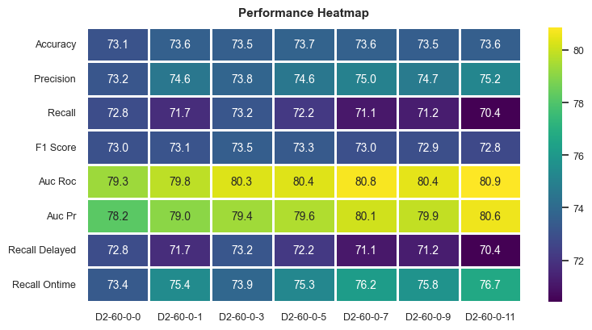

This global overview establishes the critical trade-offs at play. The next section will dissect these results in greater detail to understand the underlying drivers of performance, cost, and stability.

2.2 Detailed Analysis of the Destination Weather Experiment Family (Experience-local-D2-60-0-X)
This section provides a detailed examination of the experiment family designed to isolate and measure the effect of incorporating historical destination weather data into the flight delay prediction model. By maintaining a controlled environment, we can attribute observed changes in performance and cost directly to the single variable being tested: the depth of weather history.

2.2.1 Methodology and Controlled Variables
To ensure a fair and direct comparison, all experiments in this family shared a common, controlled configuration. The only independent variable was the weatherDestinationDepthHours parameter, which was systematically varied from 0 (baseline) to 1, 3, 5, 7, 9, and 11 hours.
All other critical parameters were held constant across the seven runs:
- Model: RandomForest (modelType: "randomforest")
- Model Hyperparameters: Key hyperparameters were fixed to ensure model architecture did not influence the results, including numTrees: 15, maxDepth: 7, and maxBins: 280.
- Dataset: D2_60, where a delay is defined as >= 60 minutes.
- Execution Environment: All experiments were run in a local environment.

2.2.2 Predictive Performance Analysis
This subsection dissects the model's predictive capabilities using a comprehensive set of metrics calculated on the hold-out test set, which the model did not see during training or cross-validation.
The table below presents a full comparison of the final test set results for each experiment.
Experiment | Accuracy | Precision | Recall (Delayed) | F1-Score | AUC-ROC
D2-60-0-0 | 73.10% | 73.22% | 72.85% | 73.03% | 0.7931
D2-60-0-1 | 73.58% | 74.55% | 71.75% | 73.12% | 0.7983
D2-60-0-3 | 73.55% | 73.78% | 73.22% | 73.50% | 0.8031
D2-60-0-5 | 73.71% | 74.58% | 72.16% | 73.35% | 0.8035
D2-60-0-7 | 73.62% | 74.97% | 71.11% | 72.99% | 0.8075
D2-60-0-9 | 73.51% | 74.73% | 71.24% | 72.95% | 0.8045
D2-60-0-11 | 73.55% | 75.23% | 70.43% | 72.75% | 0.8086
Interpreting these metrics reveals two key behavioral patterns. The F1-Score, which balances precision and recall, peaks decisively for D2-60-0-3 at 73.50% and then begins a gradual decline. This suggests that the 3-hour window provides the optimal signal-to-noise ratio for this model configuration. Additional, more distant weather data may introduce more correlational noise than predictive signal, slightly degrading the model's ability to make classifications at the optimal threshold.
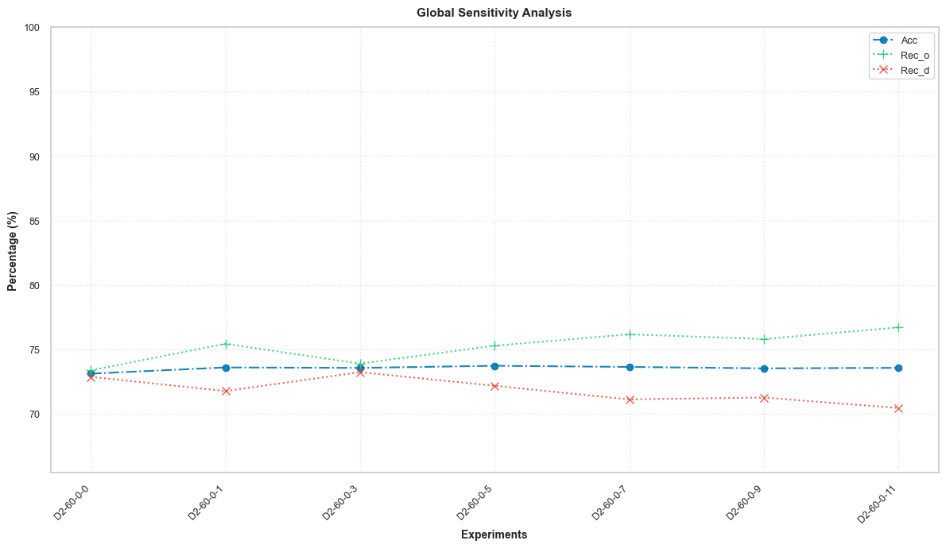

In contrast, the AUC-ROC shows a clear monotonic increase, rising from 0.7931 in the baseline to a high of 0.8086 in the 11-hour experiment. This signifies that adding more weather features consistently improves the model's fundamental ability to distinguish between the delayed and on-time classes. This consistent improvement is visually confirmed in the ROC Curves Comparison plot, where the curve for D2-60-0-11 (AUC: 0.816 in CV) is consistently positioned further to the top-left than the baseline D2-60-0-0 (AUC: 0.784 in CV), demonstrating superior performance across all thresholds.
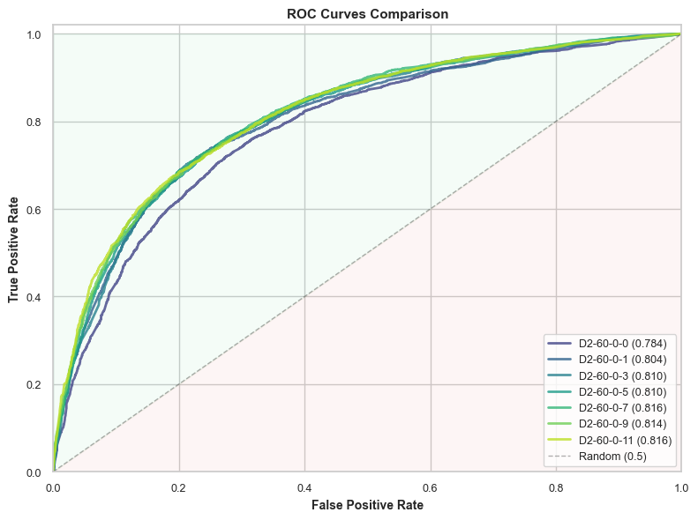

Further analysis of recall dynamics reveals an important trade-off. As weather depth increases, the model's ability to correctly identify on-time flights (Recall On-time, or RECo) generally improves (from 73.36% to 76.69%). However, this comes at the expense of its ability to correctly identify true delayed flights (Recall Delayed, or RECd), which trends downward (from 72.85% to 70.43%). This suggests that with more features, the model becomes slightly more conservative in predicting the positive (delayed) class.

2.2.3 Cross-Validation Stability Analysis
A stable model exhibits low variance in performance across different subsets of the training data. This is a critical indicator of generalizability. We measured stability by calculating the standard deviation of key metrics across the 4 cross-validation folds.
Experiment | Recall Std Dev (%) | F1-Score Std Dev (%) | AUC-ROC Std Dev (%)
D2-60-0-0 | 0.55% | 0.26% | 0.30%
D2-60-0-1 | 0.51% | 0.34% | 0.20%
D2-60-0-3 | 1.06% | 0.44% | 0.17%
D2-60-0-5 | 0.79% | 0.16% | 0.23%
D2-60-0-7 | 0.66% | 0.29% | 0.23%
D2-60-0-9 | 0.90% | 0.29% | 0.05%
D2-60-0-11 | 1.42% | 0.46% | 0.31%
The results show a notable increase in the instability of the Recall metric as weather depth increases, rising from a low of 0.51% to a high of 1.42% for the 11-hour model. This indicates that while adding more features can improve average performance (like AUC-ROC), it can also make the model less robust. The model's recall on the positive class becomes less consistent across data folds, suggesting a higher sensitivity to the specific composition of the training data.

2.2.4 Runtime and Computational Cost Analysis
Predictive performance must always be weighed against its computational cost, especially for operational systems. The following table provides a detailed breakdown of the execution time for each major stage of the pipeline.
Experiment | Data Processing (min) | Balancing (min) | Join (min) | Explode (min) | ML Pipeline (min) | Total Time (min)
D2-60-0-0 | 0.14 | 3.42 | 0.00 | 0.00 | 6.37 | 9.92
D2-60-0-1 | 0.14 | 3.37 | 12.25 | 0.15 | 6.41 | 22.34
D2-60-0-3 | 0.14 | 3.40 | 12.50 | 0.29 | 7.38 | 23.73
D2-60-0-5 | 0.14 | 3.41 | 12.66 | 0.47 | 8.20 | 24.91
D2-60-0-7 | 0.15 | 3.43 | 12.52 | 0.62 | 9.24 | 25.98
D2-60-0-9 | 0.14 | 3.45 | 12.65 | 0.85 | 9.71 | 26.84
D2-60-0-11 | 0.15 | 3.50 | 12.89 | 1.01 | 10.55 | 28.12
Two key insights emerge from this data:
- The Initial Cost of Weather: The transition from the baseline (D2-60-0-0) to the first weather-enabled model (D2-60-0-1) causes a dramatic cost increase of over 12 minutes. This overhead is driven almost entirely by the introduction of the Join and Explode stages, which are required to integrate the time-series weather data with the flight data and collectively jump from 0 to 12.4 minutes.
- Shifting Bottleneck: As weather depth increases from 1 to 11 hours, the Join cost remains relatively stable, but the primary cost driver shifts to the ML Pipeline stage. This stage's runtime increases steadily from 6.41 minutes to 10.55 minutes, indicating that the model training process itself becomes significantly more expensive as the number of input features grows.
This detailed analysis confirms a clear trade-off between performance gains and their associated computational and stability costs. The following section will explore why these changes occur by examining the features the model finds most important.

2.3 Feature Importance Deep Analysis
To understand why the model's behavior changes so significantly with the addition of weather data, this section investigates the underlying feature importances. Analyzing which data points the model considers most predictive provides direct insight into its decision-making process.

2.3.1 Baseline Feature Profile: Experience-local-D2-60-0-0
The baseline experiment, which did not include any weather data, serves as a crucial reference point. The top 5 most important features for this model were:
- indexed_DEST_AIRPORT_ID: 27.67%
- imputed_feature_flight_week_of_year_cos: 24.94%
- indexed_ORIGIN_AIRPORT_ID: 23.61%
- imputed_CRS_DEP_TIME: 10.67%
- imputed_feature_flight_week_of_year_sin: 7.02%
In the absence of meteorological data, the model relies heavily on a combination of geographical features (origin and destination airport IDs, which collectively account for over 51% of importance) and high-level temporal features (week of year and scheduled departure time).

2.3.2 The Shift in Feature Dominance with Weather Integration
The introduction of just one hour of destination weather data in experiment D2-60-0-1 caused a radical and immediate shift in feature importance. The previous top feature, indexed_DEST_AIRPORT_ID, was supplanted by dest_temp_dewpoint_spread_Min, which became the single most important predictor with an importance score of 26.44%.
The table below tracks the evolution of the single most important feature as more weather data was added.
Experiment | Top Feature Name* | Importance (%)
D2-60-0-0 | DEST_AIRPORT_ID | 27.67%
D2-60-0-1 | dest_temp_dewpoint_spread_Min | 26.44%
D2-60-0-3 | dest_RelativeHumidity_Avg | 24.01%
D2-60-0-5 | dest_RelativeHumidity_Avg | 26.75%
D2-60-0-7 | dest_RelativeHumidity_Avg | 25.96%
D2-60-0-9 | dest_RelativeHumidity_Avg | 24.07%
D2-60-0-11 | dest_RelativeHumidity_Avg | 22.00%
Feature names are shortened for clarity. The dest_ prefix indicates a destination weather feature.
This evolution is telling. After the initial introduction of weather data, the model consistently identifies features related to atmospheric moisture at the destination—average relative humidity and the spread between temperature and dewpoint—as the primary predictors of flight delays. These meteorological variables are demonstrably more influential than any single geographical, carrier, or temporal feature.

2.3.3 Aggregate Importance of Weather Features
To quantify the total contribution of weather, we summed the importance scores of all destination weather-related features for each experiment. This aggregate value was calculated by summing the Gini importance of all features prefixed with destination_weather_ in the feature importance report for each experiment.

Weather Depth (Hours) | Total Weather Feature Importance (%)
1 | 28.00%
3 | 28.41%
5 | 28.71%
7 | 28.30%
9 | 26.39%
11 | 24.73%
The analysis reveals that the total contribution of weather features peaks at the 5-hour mark and then begins to decline. This trend strongly corroborates the "diminishing returns" observed in the F1-Score. The model appears to gain the most value from the first few hours of weather data. This suggests that beyond the 5-hour mark, the additional, more temporally distant weather features begin to introduce more noise than signal, diluting the predictive power of the core meteorological variables and leading to the observed decay in both F1-Score and aggregate feature importance.
This deep dive into feature importance provides a clear explanation for the observed performance trends, confirming that destination weather is a powerful but nuanced predictor.

Local-D2-60-X-0 Experience Set
This set of experiments is designed to isolate and quantify the impact of incorporating origin weather data at varying temporal depths on model performance, computational cost, and feature importance. The primary objective is to determine the optimal depth of historical origin weather and to directly compare its predictive power against the destination weather experiments analyzed in the previous section. By systematically varying only the origin weather depth from 1 to 11 hours, we can attribute all observed changes in model behavior to this single factor.
The analysis reveals a clear and compelling case for the superiority of origin weather data. Key findings include:
- Optimal Performance: The model's F1-Score, a balanced measure of precision and recall, peaks at an impressive 75.85% when incorporating 9 hours of origin weather history.
- Sustained Discriminatory Power: Unlike the F1-Score, the model's fundamental ability to distinguish between delayed and on-time flights (AUC-ROC) improves monotonically with increased weather depth, reaching a maximum of 0.8286.
- Significant Performance Lift: The introduction of origin weather provides a substantial and immediate uplift in predictive performance over the baseline model, though it also incurs a notable increase in computational cost, primarily due to data joining operations.
- Complementary Predictive Signal: Origin weather features consistently rank among the most important predictors. However, unlike destination weather, they do not completely displace core geographical and temporal features, suggesting they provide a powerful complementary signal rather than a single dominant one.
This global synthesis establishes that integrating origin weather is a highly effective strategy for improving model accuracy, a conclusion that will be explored in detail in the following subsections.

3.1 Global Synthesis of Experimental Results
This subsection provides a high-level, comparative overview of the seven experiments conducted in this family. The goal is to establish a baseline understanding of the global trends in model performance and computational cost as a function of origin weather data depth, from the baseline with no weather data to the model incorporating 11 hours of history.
The table below summarizes the key outcomes for each experiment.
Experiment Name | Weather Depth (Hours) | Hold-out F1-Score (%) | Hold-out AUC-ROC | Total Execution Time (min)
D2-60-0-0 | 0 | 73.03% | 0.7931 | 9.92
D2-60-1-0 | 1 | 74.08% | 0.8068 | 22.78
D2-60-3-0 | 3 | 74.78% | 0.8077 | 23.27
D2-60-5-0 | 5 | 74.83% | 0.8131 | 24.24
D2-60-7-0 | 7 | 75.24% | 0.8189 | 25.30
D2-60-9-0 | 9 | 75.85% | 0.8215 | 26.30
D2-60-11-0 | 11 | 75.64% | 0.8286 | 27.06
The data reveals a compelling narrative of trade-offs. We observe a non-linear relationship for the F1-Score, which steadily improves with added weather data before peaking at D2-60-9-0 and then slightly declining. This suggests that the 9-hour window achieves the optimal balance of precision and recall. In contrast, both the AUC-ROC and Total Execution Time show a monotonic increase. This indicates that while the model's underlying discriminatory power continues to improve with more data, this comes at a direct computational cost and does not guarantee an improvement in the classification metric that balances false positives and false negatives.
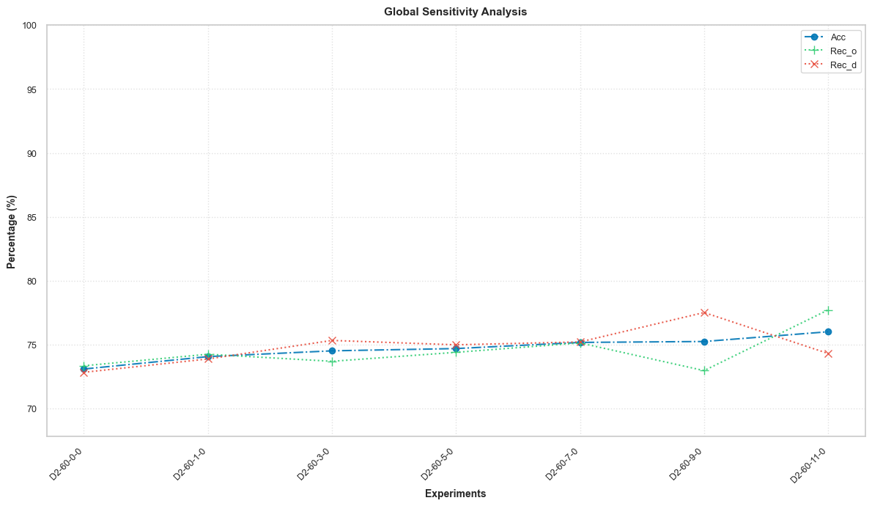

This high-level overview demonstrates the significant value of origin weather data. The following detailed analysis will unpack the specific drivers behind these performance and cost trends.

3.2 Detailed Analysis of the Origin Weather Experiment Family (Experience-local-D2-60-X-0)
A granular analysis of the origin weather experiments reveals a direct causal link between increasing weather depth, improved model performance, and escalating computational costs. By holding all other variables constant, any observed changes can be attributed solely to the depth of origin weather history, allowing for a precise evaluation of its impact.

3.2.1 Methodology and Controlled Variables
The experimental setup was rigorously controlled to isolate the effect of a single independent variable: weatherOriginDepthHours. This parameter was systematically varied across six experiments (1, 3, 5, 7, 9, and 11 hours) and compared against the D2-60-0-0 baseline, which contained no weather data.
All critical parameters were held constant across all runs:
- Model: RandomForest (modelType: "randomforest")
- Model Hyperparameters: Key settings were fixed to ensure architectural consistency: numTrees (15), maxDepth (7), and maxBins (280).
- Dataset: D2_60 (flights with a delay greater than or equal to 60 minutes are labeled as positive).
- Execution Environment: All experiments were executed in a local environment.

3.2.2 Predictive Performance Analysis
A detailed performance analysis reveals a crucial trade-off: while the model's fundamental discriminatory power (AUC-ROC) improves with all available data, the optimal precision-recall balance (F1-Score) is achieved at a finite 9-hour weather depth. This subsection dissects the model's predictive capabilities using a comprehensive set of metrics calculated on the hold-out test set for an unbiased assessment of generalization performance.
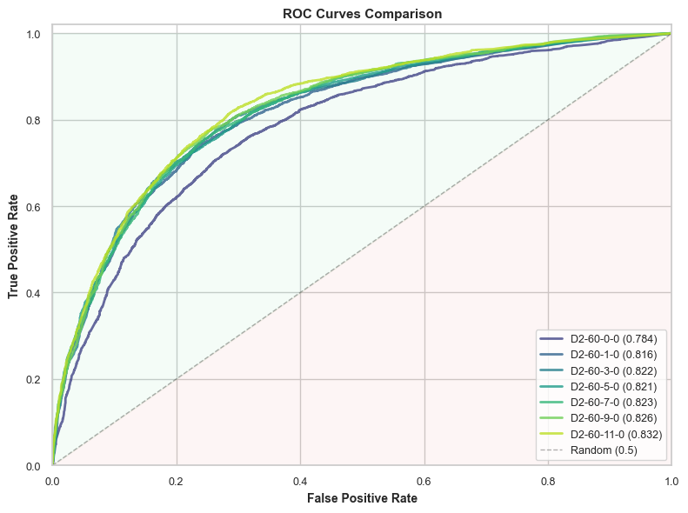

The table below presents a full comparison of the final test results for each experiment in the D2-60-X-0 series.
Experiment | Accuracy | Precision | Recall (Delayed) | F1-Score | AUC-ROC
D2-60-1-0 | 74.07% | 74.27% | 73.89% | 74.08% | 0.8068
D2-60-3-0 | 74.53% | 74.23% | 75.34% | 74.78% | 0.8077
D2-60-5-0 | 74.70% | 74.65% | 75.00% | 74.83% | 0.8131
D2-60-7-0 | 75.18% | 75.25% | 75.22% | 75.24% | 0.8189
D2-60-9-0 | 75.26% | 74.24% | 77.52% | 75.85% | 0.8215
D2-60-11-0 | 76.02% | 77.01% | 74.32% | 75.64% | 0.8286
The performance trends reveal a nuanced relationship between data depth and predictive power.
- F1-Score Analysis: The F1-Score shows a clear pattern of improvement, rising steadily as more origin weather data is added. It reaches a distinct peak of 75.85% for the D2-60-9-0 experiment before a slight dip in the 11-hour model. This indicates that the 9-hour window provides the optimal signal-to-noise ratio for balancing precision and recall.
- AUC-ROC Analysis: In contrast, the AUC-ROC exhibits a monotonically increasing trend, climbing from 0.8068 (D2-60-1-0) to a high of 0.8286 (D2-60-11-0). This signifies a consistent improvement in the model's fundamental ability to distinguish between delayed and on-time flights as more features are added. The visual superiority of the ROC curve for later models in the comparison chart demonstrates better class separation, a conclusion directly corroborated by the rising hold-out AUC scores presented in the table.
- Recall Dynamics: An analysis of the trade-off between recall for delayed flights (RECd) and on-time flights (RECo) reveals a shifting model bias. RECd generally improves up to the 9-hour mark, peaking at an excellent 77.52%, before falling in the final experiment. Conversely, RECo trends in the opposite direction, bottoming out at 72.98% for the 9-hour model before rising again. This demonstrates how the model adjusts its classification bias as the feature space expands.

3.2.3 Cross-Validation Stability Analysis
Model stability, defined as low variance in performance across different training data subsets, is crucial for reliable production deployment. We measure this using the standard deviation of metrics over the 4 cross-validation folds.
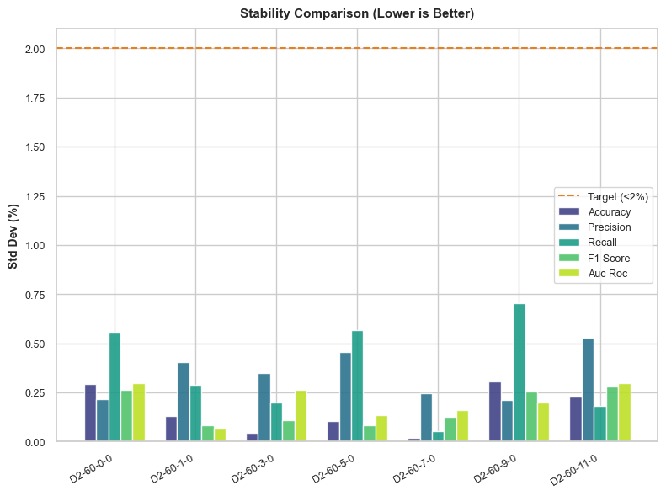

Experiment | Recall Std Dev (%) | F1-Score Std Dev (%) | AUC-ROC Std Dev (%)
D2-60-1-0 | 0.29% | 0.08% | 0.07%
D2-60-3-0 | 0.20% | 0.11% | 0.26%
D2-60-5-0 | 0.57% | 0.08% | 0.13%
D2-60-7-0 | 0.05% | 0.12% | 0.16%
D2-60-9-0 | 0.70% | 0.25% | 0.20%
D2-60-11-0 | 0.18% | 0.28% | 0.30%
While all experiments remain well below the 2% instability target, the data does not show a simple, clear trend. Notably, D2-60-9-0, which achieved the best F1-Score, also exhibits the highest instability for the Recall metric (0.70%). This suggests a potential "overfitting" to specific characteristics of the training distribution for that metric. While 9 hours is optimal for the F1-score on this particular hold-out set, a slightly more stable model like D2-60-7-0 might generalize better in production, presenting a clear performance-versus-stability trade-off for the engineering team.

3.2.4 Runtime and Computational Cost Analysis
The analysis of computational cost reveals that performance gains from origin weather come with a significant, but predictable, increase in resource consumption. Weighing predictive performance against this cost is essential for building efficient and scalable systems.
The table below breaks down the execution time for each major stage of the data and machine learning pipeline.
Experiment | Data Processing (min) | Balancing (min) | Join (min) | Explode (min) | ML Pipeline (min) | Total Time (min)
D2-60-1-0 | 0.14 | 3.43 | 12.46 | 0.15 | 6.57 | 22.78
D2-60-3-0 | 0.14 | 3.38 | 12.41 | 0.28 | 7.04 | 23.27
D2-60-5-0 | 0.14 | 3.38 | 12.37 | 0.44 | 7.89 | 24.24
D2-60-7-0 | 0.14 | 3.38 | 12.46 | 0.60 | 8.70 | 25.30
D2-60-9-0 | 0.14 | 3.38 | 12.43 | 0.79 | 9.53 | 26.30
D2-60-11-0 | 0.14 | 3.37 | 12.42 | 0.96 | 10.15 | 27.06
The data reveals two primary drivers of computational cost:
- Fixed, One-Time Cost: Introducing origin weather features incurs a substantial initial overhead of over 12 minutes compared to the baseline. This is a fixed, one-time cost for enabling weather features, almost entirely attributable to the computationally expensive Join stage (12.46 min), which merges flight records with their corresponding time-series weather data.
- Variable Cost Scaling with Dimensionality: As weather depth increases, the primary cost driver shifts from the fixed Join stage to the ML Pipeline stage. This is a variable cost that scales linearly with feature dimensionality. The ML Pipeline runtime grows steadily from 6.57 minutes (D2-60-1-0) to 10.15 minutes (D2-60-11-0), directly reflecting the increased computational burden of training a RandomForest model on a wider feature set.
To understand why these performance and cost changes occur, the next section examines which features the model finds most predictive.

3.3 Feature Importance Deep Analysis
This section investigates the underlying feature importances to understand why the model's behavior and performance change with the addition of origin weather data. By analyzing what the model learns, we can connect the input data to the predictive outcomes.

3.3.1 Baseline Feature Profile: Experience-local-D2-60-0-0
As a point of reference, the baseline model (D2-60-0-0), which lacked any weather data, relied heavily on geographical and temporal predictors. The most influential features were indexed_DEST_AIRPORT_ID, indexed_ORIGIN_AIRPORT_ID, and the cosine transformation of the week of the year (imputed_feature_flight_week_of_year_cos), which together accounted for the vast majority of the model's predictive power.

3.3.2 The Shift in Feature Dominance with Weather Integration
The introduction of origin weather data significantly alters the feature importance landscape. The table below tracks the top four most important features and their relative importance for each experiment in the series.
Experiment | Rank 1 Feature | Rank 2 Feature | Rank 3 Feature | Rank 4 Feature
D2-60-1-0 | indexed_DEST_AIRPORT_ID  (29.36%) | imputed_origin_weather_feature_temp_dewpoint_spread_Min  (24.77%) | imputed_feature_flight_week_of_year_cos  (19.06%) | indexed_ORIGIN_AIRPORT_ID  (12.73%)
D2-60-3-0 | indexed_DEST_AIRPORT_ID  (29.23%) | imputed_origin_weather_RelativeHumidity_Avg (25.43%) | imputed_feature_flight_week_of_year_cos  (18.48%) | indexed_ORIGIN_AIRPORT_ID  (12.98%)
D2-60-5-0 | indexed_DEST_AIRPORT_ID (29.51%) | imputed_origin_weather_RelativeHumidity_Avg (22.90%) | imputed_feature_flight_week_of_year_cos (16.85%) | indexed_ORIGIN_AIRPORT_ID (12.15%)
D2-60-7-0 | indexed_DEST_AIRPORT_ID (27.44%) | imputed_origin_weather_RelativeHumidity_Avg (21.25%) | imputed_feature_flight_week_of_year_cos (18.06%) | indexed_ORIGIN_AIRPORT_ID (12.93%)
D2-60-9-0 | indexed_DEST_AIRPORT_ID (27.45%) | imputed_origin_weather_RelativeHumidity_Avg (18.17%) | imputed_feature_flight_week_of_year_cos (16.91%) | indexed_ORIGIN_AIRPORT_ID (12.34%)
D2-60-11-0 | imputed_feature_flight_week_of_year_cos (24.11%) | indexed_DEST_AIRPORT_ID (22.59%) | indexed_ORIGIN_AIRPORT_ID (14.38%) | imputed_CRS_DEP_TIME (6.22%)
This evolution reveals a fascinating pattern. Unlike the destination weather experiments where weather features immediately seized the top rank, origin weather features act as powerful co-predictors. Core geographical features like indexed_DEST_AIRPORT_ID and indexed_ORIGIN_AIRPORT_ID, along with the seasonal imputed_feature_flight_week_of_year_cos, remain highly dominant. However, key origin weather features, particularly imputed_origin_weather_RelativeHumidity_Avg and imputed_origin_weather_feature_temp_dewpoint_spread_Min, consistently appear in the top 5, demonstrating their significant predictive value. The final experiment, D2-60-11-0, shows an interesting shift where the seasonality feature overtakes airport IDs, indicating a complex interplay between predictors as the feature space grows.

3.3.3 Aggregate Importance of Weather Features
To quantify the total contribution of origin weather to the model's decision-making, the importance scores of all origin weather-related features were summed for each experiment.
Weather Depth (Hours) | Total Origin Weather Feature Importance (%)
1 | 27.98%
3 | 28.13%
5 | 27.10%
7 | 25.19%
9 | 22.39%
11 | 23.47%
The analysis reveals a critical divergence: the aggregate importance of origin weather features peaks early at the 3-hour mark, while the F1-Score peaks much later at 9 hours. This suggests that the initial weather features provide the most potent, unique signal to the model. Later features (from hours 4-9) likely offer smaller, incremental gains that, while having lower individual Gini importance or some informational redundancy, are crucial for refining the model's precision-recall balance and pushing the F1-Score to its optimal point.

3.4 Comparative Analysis: Origin vs. Destination Weather Impact
This section conducts a direct comparison between the Local-D2-60-0-X (destination weather) and Local-D2-60-X-0 (origin weather) experiment sets. The goal is to provide a definitive, data-driven answer to which weather source—at origin or destination—is more predictive, cost-effective, and ultimately more valuable for the flight delay prediction task.

3.4.1 Head-to-Head Performance Comparison
The evidence is conclusive: the Local-D2-60-X-0 experiment set, which incorporates origin weather data, demonstrates definitively superior predictive performance.
The table below compares the best-performing model from each family, selected based on the highest achieved F1-Score on the hold-out test set.
Metric | Best Destination Model (D2-60-0-3) | Best Origin Model (D2-60-9-0)
Hold-out F1-Score | 73.50% | 75.85%
Hold-out AUC-ROC | 0.8031 | 0.8215
Total Execution Time (min) | 23.73 | 26.30
The best origin model provides a significant performance lift across the board. It achieves an F1-Score of 75.85% compared to 73.50% for the best destination model—a substantial improvement of over 2.3 percentage points. This superiority is systemic; the top three models in the origin weather family all achieve an F1-Score above 75%, a threshold no destination weather model reached.

3.4.2 Feature Dominance and Predictive Power
The feature importance analyses from both experiment sets reveal fundamentally different model behaviors.
- Destination Weather: When introduced, destination weather features (e.g., imputed_destination_weather_RelativeHumidity_Avg) immediately became the single most dominant predictors, supplanting all other geographical and temporal features.
- Origin Weather: In contrast, origin weather features, while highly influential and consistently ranked in the top 5, did not displace the core geographical (indexed_DEST_AIRPORT_ID) and temporal (imputed_feature_flight_week_of_year_cos) features with the same decisiveness. They acted as powerful complementary predictors.
This suggests that while destination weather introduces a new and dominant signal about conditions upon arrival, origin weather provides a rich, complementary signal that enhances the model's understanding of conditions at the point of departure without overshadowing existing high-value features.

3.4.3 Cost-Benefit Analysis
A crucial part of the comparison is evaluating the computational trade-offs required to achieve peak performance.
- Destination: Peak F1-Score (73.50%) was achieved with D2-60-0-3 at a computational cost of 23.73 minutes.
- Origin: Peak F1-Score (75.85%) was achieved with D2-60-9-0 at a computational cost of 26.30 minutes.
The conclusion is clear: the origin weather experiments deliver a substantial performance gain of +2.35 percentage points on F1-Score for only a marginal increase in computational cost of +2.57 minutes. This represents a highly efficient investment of resources for a significant improvement in predictive accuracy.

3.4.4 Strategic Conclusion
Based on a comprehensive review of performance, cost, and feature dynamics, the verdict is unequivocal: incorporating origin weather data is strategically superior to using destination weather data for this modeling task. This conclusion is firmly supported by its significantly higher predictive accuracy (both F1-Score and AUC-ROC) and its excellent cost-benefit profile.
Therefore, it is recommended that future model development and optimization efforts should prioritize the use and refinement of origin weather features as the primary meteorological input for the flight delay prediction system.

4. Local-D2-60-X-X Experience Set: Symmetric Weather Integration Analysis
This set of experiments evaluates the impact of integrating both origin and destination weather data simultaneously, utilizing symmetric temporal depths (e.g., 3 hours of origin weather and 3 hours of destination weather). The primary objective is to determine if this combined, feature-rich approach yields a significant performance improvement over using a single weather source, such as origin-only data. A secondary goal is to analyze the associated trade-offs in computational cost and model complexity that arise from doubling the weather-related feature space. This analysis is critical for identifying the point of diminishing returns in data enrichment and for making a data-driven decision on the optimal modeling strategy.

4.1 Global Synthesis of Experimental Results
This overview provides a high-level comparison of model performance and computational cost across the symmetric weather experiments, systematically increasing the weather depth from 1 hour to 11 hours. This initial analysis is designed to identify broad trends in the relationship between feature dimensionality, predictive accuracy, and resource consumption. By examining these global metrics, we can locate the peak-performing model configuration and establish the context for a more granular examination of its behavior.
High-Level Performance and Cost Metrics for Symmetric Weather Models
Experiment Name | Symmetric Weather Depth (Hours) | Hold-out F1-Score (%) | Hold-out AUC-ROC | Total Execution Time (min)
D2-60-1-1 | 1 | 75.26% | 0.8198 | 29.89
D2-60-3-3 | 3 | 75.86% | 0.8317 | 35.18
D2-60-5-5 | 5 | 76.18% | 0.8306 | 52.50
D2-60-7-7 | 7 | 76.40% | 0.8353 | 43.58
D2-60-9-9 | 9 | 76.75% | 0.8363 | 54.35
D2-60-11-11 | 11 | 76.69% | 0.8417 | 60.36
The key trends revealed in the data are multifaceted. There is a non-linear relationship between weather depth and the F1-Score, which steadily improves before peaking at 76.75% with the D2-60-9-9 experiment and then slightly declining. This suggests that a 9-hour symmetric window provides the optimal signal-to-noise ratio for this balanced classification metric. In contrast, Total Execution Time shows a strong upward trend correlated with feature depth, though with a notable outlier in the D2-60-7-7 experiment, which completed faster than several less complex runs. While adding more data consistently improves the model's underlying discriminatory power, it comes at a significant and escalating computational cost. This divergence demonstrates that maximizing feature volume does not guarantee optimal performance on balanced metrics like the F1-Score, setting the stage for the detailed analysis to follow.

4.2 Detailed Analysis of the Symmetric Weather Experiment Family (Experience-local-D2-60-X-X)
This section provides a granular examination of the symmetric weather experiments. The following subsections will cover the precise methodology, a comprehensive breakdown of predictive performance, an assessment of model stability, and an analysis of the computational costs incurred, thereby building a complete picture of their behavior.

4.2.1 Methodology and Controlled Variables
The methodology for this experiment family was designed to isolate the impact of increasing symmetric weather depth. The single independent variable was the temporal depth, applied equally to both weatherOriginDepthHours and weatherDestinationDepthHours and varied from 1 to 11 hours across the experiments. To ensure a direct and fair comparison, all other critical parameters were held constant across every run.
- Model: RandomForest
- Model Hyperparameters: numTrees: 15, maxDepth: 7, maxBins: 280
- Dataset: D2_60
- Execution Environment: Local

4.2.2 Predictive Performance Analysis
This subsection dissects the model's predictive capabilities on the hold-out test set, which provides an unbiased assessment of its ability to generalize to unseen data. The goal is to understand the nuanced relationship between increasing the feature dimensionality through symmetric weather data and the resulting performance on key classification metrics.
Hold-out Test Set Performance Comparison
Experiment | Accuracy | Precision | Recall (Delayed) | F1-Score | AUC-ROC
D2-60-1-1 | 75.32% | 75.75% | 74.77% | 75.26% | 0.8198
D2-60-3-3 | 75.74% | 75.80% | 75.92% | 75.86% | 0.8317
D2-60-5-5 | 75.98% | 75.85% | 76.51% | 76.18% | 0.8306
D2-60-7-7 | 76.47% | 76.43% | 76.38% | 76.40% | 0.8353
D2-60-9-9 | 76.65% | 76.71% | 76.80% | 76.75% | 0.8363
D2-60-11-11 | 77.07% | 77.66% | 75.75% | 76.69% | 0.8417

An analytical summary of these performance trends reveals several key dynamics:
- F1-Score Analysis: The F1-Score, which balances precision and recall, exhibits a clear upward trend that peaks at 76.75% for the D2-60-9-9 experiment. Beyond this point, the score plateaus and slightly declines, suggesting that the 9-hour depth represents the optimal signal-to-noise ratio for this balanced metric. Adding more distant weather data does not contribute to a better precision-recall trade-off.
- AUC-ROC Analysis: In contrast, the AUC-ROC shows a strong, near-monotonic upward trend as weather depth increases, culminating at 0.8417 for the D2-60-11-11 model. There is one minor plateau, with the value for D2-60-5-5 (0.8306) dipping slightly from D2-60-3-3 (0.8317). Overall, this trend signifies a continuous improvement in the model's fundamental ability to separate the positive and negative classes. Even when the F1-score stagnates, the model's underlying discriminatory power is still being enhanced by the additional features.
- Recall Dynamics: The trade-off between identifying delayed flights (RECd) and on-time flights (RECo) shifts with added data. RECd improves steadily up to the 9-hour mark, peaking at 76.80%, before dropping in the 11-hour experiment. Conversely, RECo (recall for on-time flights) sees a notable jump in the final experiment to 78.38%. This indicates a change in the model's classification bias at the highest feature counts.
This detailed look at performance underscores the complexity of model behavior, making it crucial to also assess its stability.

4.2.3 Cross-Validation Stability Analysis
Model stability, measured by the standard deviation of metrics across cross-validation folds, is a critical indicator of a model's ability to generalize to new, unseen data. A model with low variance is considered more robust and reliable for production deployment.
Cross-Validation Metric Stability (Standard Deviation)
Experiment | Recall Std Dev (%) | F1-Score Std Dev (%) | AUC-ROC Std Dev (%)
D2-60-1-1 | 0.75% | 0.45% | 0.21%
D2-60-3-3 | 0.68% | 0.62% | 0.53%
D2-60-5-5 | 0.25% | 0.34% | 0.53%
D2-60-7-7 | 0.56% | 0.23% | 0.21%
D2-60-9-9 | 0.16% | 0.16% | 0.11%
D2-60-11-11 | 0.63% | 0.32% | 0.21%
The analysis shows that all models exhibit low variance across key metrics, with standard deviations well within acceptable stability limits (e.g., <2%). Notably, the best-performing model, D2-60-9-9, also demonstrates excellent stability, posting the lowest standard deviation for both Recall (0.16%) and F1-Score (0.16%). This high stability reinforces its viability as a candidate model, indicating that its strong performance is not an artifact of a specific data split. However, both performance and stability must be weighed against their associated computational expense.
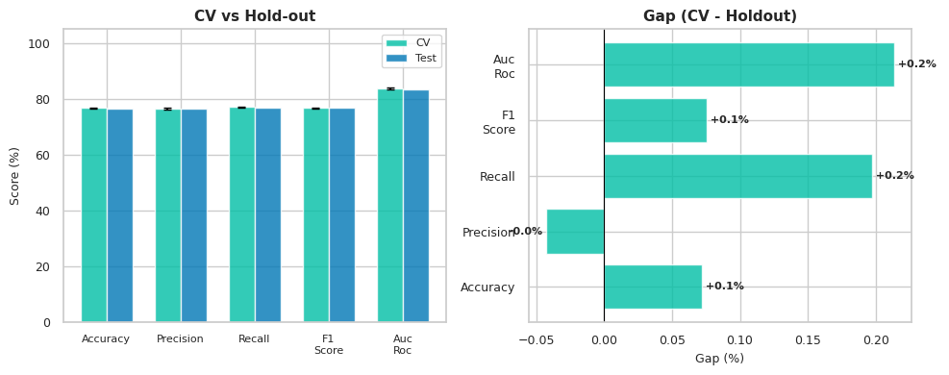
D2-60-9-9 - CV vs HoldOut Comparison

4.2.4 Runtime and Computational Cost Analysis
This subsection evaluates the computational cost associated with the performance gains achieved by integrating symmetric weather data. Understanding the resource consumption of each pipeline stage is essential for assessing the operational feasibility and scalability of each model configuration.
Execution Time Breakdown by Pipeline Stage (minutes)
Experiment | Data Processing (min) | Join (min) | Explode (min) | ML Pipeline (min) | Total Time (min)
D2-60-1-1 | 6.37 | 12.85 | 0.94 | 5.20 | 29.89
D2-60-3-3 | 8.61 | 12.52 | 5.28 | 3.94 | 35.18
D2-60-5-5 | 5.95 | 15.11 | 8.32 | 18.29 | 52.50
D2-60-7-7 | 5.48 | 10.79 | 12.72 | 9.79 | 43.58
D2-60-9-9 | 6.11 | 10.29 | 18.13 | 15.13 | 54.35
D2-60-11-11 | 5.39 | 11.50 | 23.19 | 15.65 | 60.36
An analysis of the runtime data reveals several cost drivers:
- Escalating Cost: There is a significant increase in total execution time as the symmetric weather depth increases. The runtime roughly doubles, rising from approximately 30 minutes for the 1-hour model to over 60 minutes for the 11-hour model, highlighting the substantial computational burden of processing a larger feature set.
- Shifting Bottlenecks: The Join, Explode, and ML Pipeline stages are the primary cost drivers. In the initial experiments, the Join operation is a major contributor. However, as weather depth increases, the cost of the Explode and ML Pipeline stages scales directly with the number of features. These two stages become the dominant bottlenecks in the deeper experiments, with Explode time growing from under one minute to over 23 minutes.
- Runtime Anomaly Investigation: The runtime for D2-60-7-7 presents a notable anomaly, completing nearly 9 minutes faster than the preceding D2-60-5-5 experiment despite a larger feature set. The time savings are primarily concentrated in the Join (10.79 min vs 15.11 min) and ML Pipeline (9.79 min vs 18.29 min) stages. This suggests a potential variance in execution environment performance or resource contention during that specific run and warrants a closer look at the execution logs to rule out external factors.
To understand what the model is learning from this increasingly costly data, we turn next to a feature importance analysis.

4.3 Feature Importance Deep Analysis
To understand why performance improves with symmetric weather data, it is essential to analyze which features the model finds most predictive. By examining the Gini importance assigned to each feature, we can gain insight into the model's decision-making process. This analysis will investigate the interplay between core non-weather features and the newly introduced origin and destination weather features, revealing their collective impact.
Evolution of Top 5 Feature Importances
Experience-local-D2-60-1-1-feature_importances_report.txt
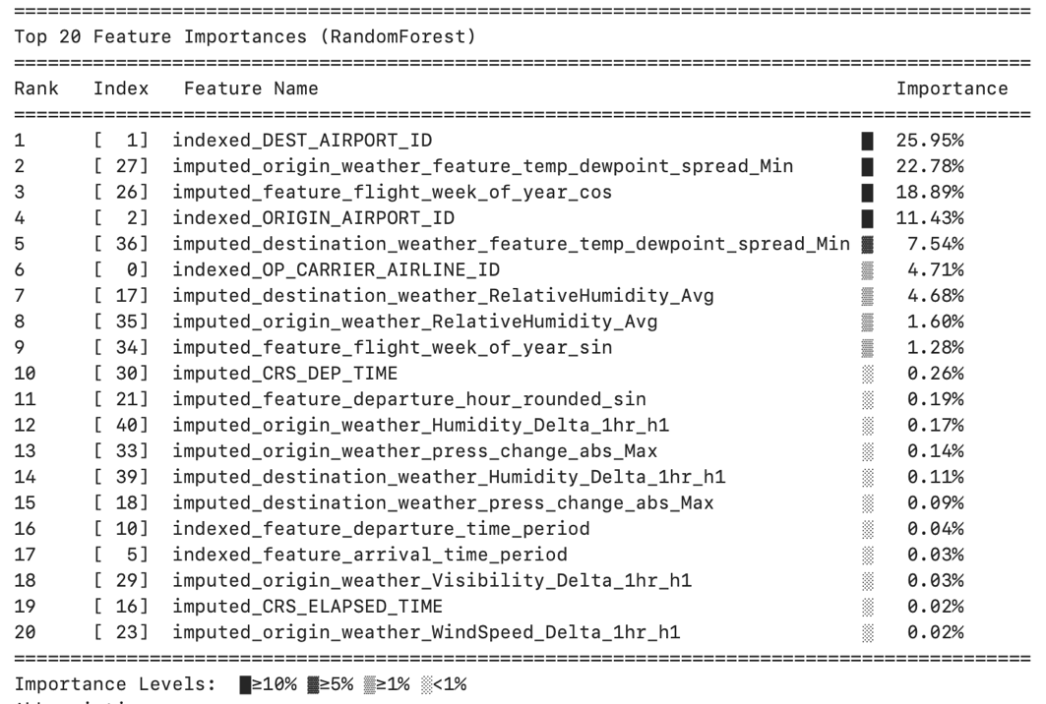
_
Experience-local-D2-60-3-3-feature_importances_report.txt
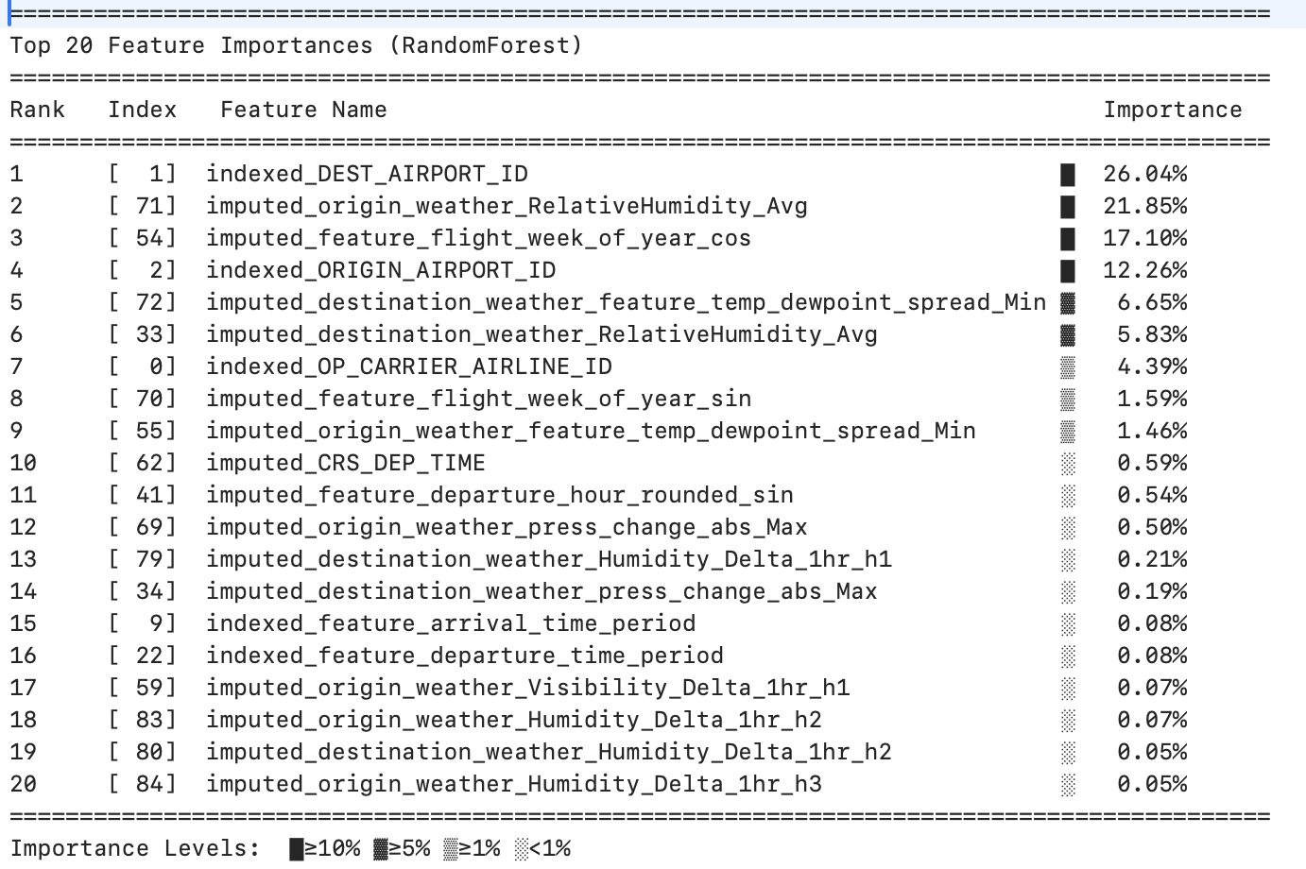
Experience-local-D2-60-7-7-feature_importances_report.txt
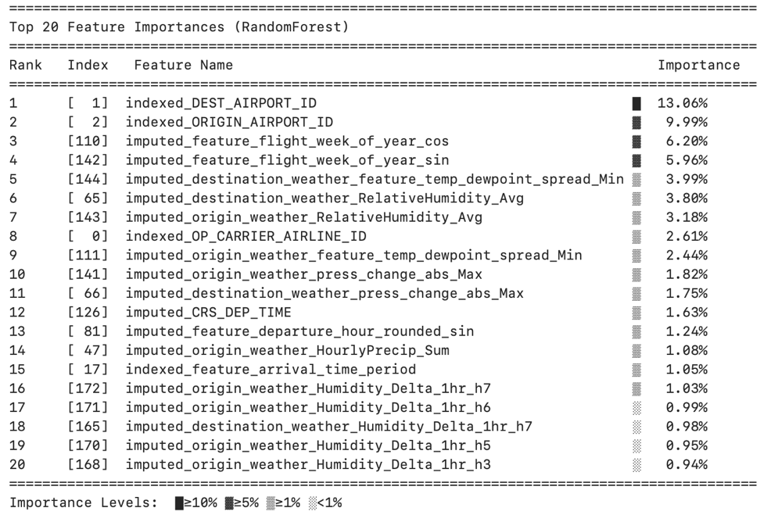

Experience-local-D2-60-9-9-feature_importances_report.txt
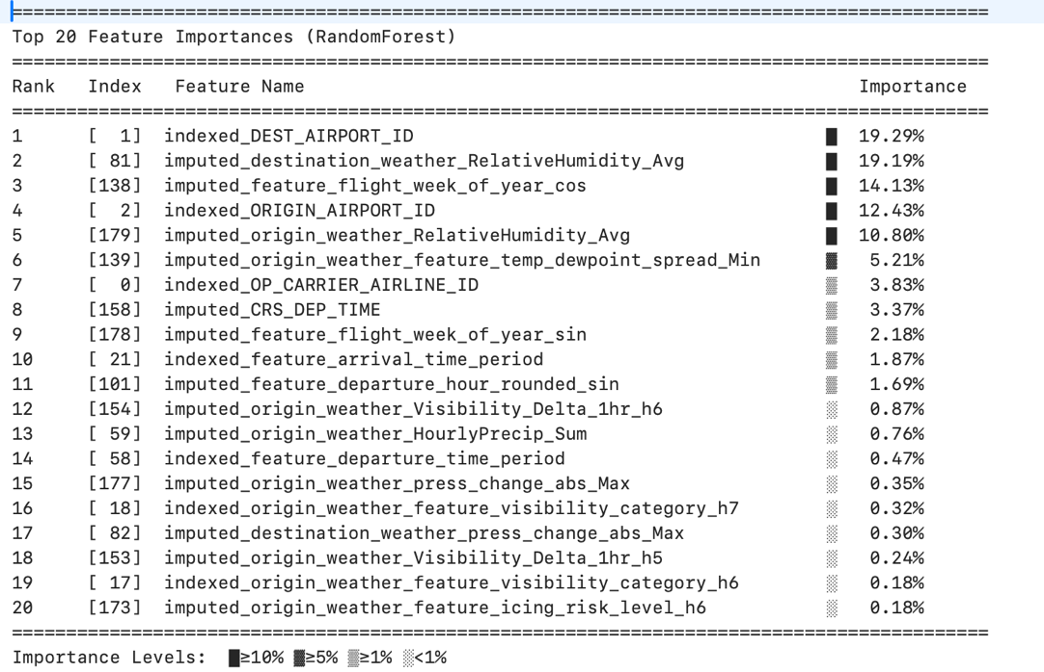
Experience-local-D2-60-11-11-feature_importances_report.txt
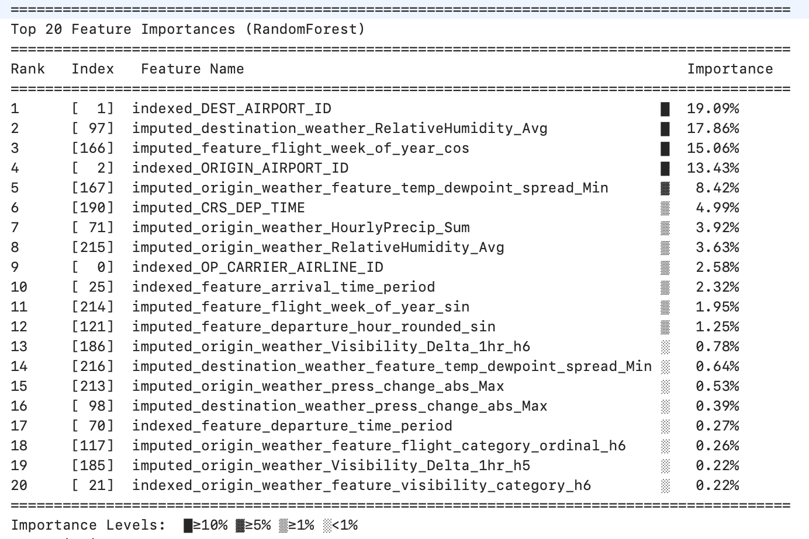

Experiment | Rank 1 | Rank 2 | Rank 3 | Rank 4 | Rank 5
D2-60-1-1 | Feature_1 (24.77%) | Feature_27 (21.12%) | Feature_26 (15.27%) | Feature_2 (11.81%) | Feature_36 (10.84%)
D2-60-3-3 | Feature_1 (25.66%) | Feature_71 (20.88%) | Feature_54 (13.60%) | Feature_2 (12.00%) | Feature_33 (7.94%)
D2-60-5-5 | Feature_49 (21.66%) | Feature_1 (20.62%) | Feature_2 (13.39%) | Feature_107 (11.24%) | Feature_82 (9.38%)
D2-60-7-7 | Feature_65 (20.98%) | Feature_1 (19.46%) | Feature_2 (13.31%) | Feature_143 (11.70%) | Feature_110 (9.82%)
D2-60-9-9 | Feature_81 (19.19%) | Feature_1 (19.07%) | Feature_138 (12.66%) | Feature_2 (12.19%) | Feature_179 (10.74%)
D2-60-11-11 | Feature_1 (18.83%) | Feature_97 (17.78%) | Feature_166 (13.51%) | Feature_2 (12.83%) | Feature_167 (7.68%)
Analyzing the dynamics of feature importance across these experiments reveals a key pattern:
- Blended Influence: Unlike the single-source weather experiments where one data type sometimes dominated, the top-ranked features here are consistently a mix of non-weather features (e.g., Feature_1, Feature_2) and high-importance features derived from both origin and destination weather sources. For example, in D2-60-9-9, origin (Feature_81) and destination (Feature_138, Feature_179) weather features share top billing with core predictors.
- No Single Dominant Source: This consistent blending demonstrates that neither origin nor destination weather data completely dominates the other. Instead, the model effectively leverages signals from both sources simultaneously. This complementarity is the likely driver behind the superior performance of the symmetric models. While single-source models optimize around one set of conditions, the symmetric model can capture more complex interaction effects (e.g., how poor weather at origin is amplified by marginal weather at the destination), leading to the higher F1-Score and AUC-ROC observed in the D2-60-9-9 model.
The next section will quantify the ultimate value of this combined, complementary approach by comparing it directly to the single-source champion.

4.4 Comparative Analysis: Symmetric vs. Single-Source Weather Impact
This final analysis directly compares the best-performing symmetric weather model against the champion from the origin-only experiment family (D2-60-X-0). The objective is to deliver a definitive, data-driven verdict on the strategic value of incorporating both weather sources versus a more streamlined, single-source approach, weighing the marginal performance gain against the significant increase in computational cost.

4.4.1 Head-to-Head Performance Comparison
The following table pits the best symmetric model (D2-60-9-9) against the best origin-only model (D2-60-9-0) based on their peak F1-Scores.
Peak Performance Comparison Across Experiment Families
Metric | Best Origin Model  (D2-60-9-0) | Best Symmetric Model  (D2-60-9-9)
Hold-out F1-Score | 75.85% | 76.75%
Hold-out AUC-ROC | 0.8215 | 0.8363
Total Execution Time (min) | 26.30 | 54.35
The data shows that the symmetric weather model (D2-60-9-9) achieves the highest absolute performance, delivering a measurable, albeit modest, improvement on both the F1-Score and AUC-ROC over the best origin-only model.

4.4.2 Cost-Benefit Analysis
A direct cost-benefit analysis based on the comparison table reveals a clear case of diminishing returns.
- Quantify the Gain: The symmetric D2-60-9-9 model provides a performance lift of +0.9 percentage points on the F1-Score compared to the D2-60-9-0 model.
- Quantify the Cost: Crucially, this marginal gain comes at a massive computational cost. The total execution time increases from 26.30 minutes for the origin-only model to 54.35 minutes for the symmetric model—more than doubling the runtime.
- Calculate Efficiency: The symmetric model is significantly less efficient, requiring an additional 28.05 minutes of computation for less than one percentage point of F1-Score improvement.

4.4.3 Strategic Conclusion
While using both origin and destination weather data yields the highest absolute performance, it demonstrates a clear case of diminishing returns. The substantial increase in computational cost is not justified by the marginal gain in predictive accuracy. Furthermore, the simpler feature space of the origin-only model reduces pipeline complexity, lowers data-sourcing dependencies, and simplifies model monitoring and maintenance in a production environment. Therefore, for a combination of predictive performance and operational efficiency, the origin-only model (D2-60-9-0) represents the optimal strategic choice. It provides a near-peak level of performance at a much more favorable computational cost, making it the most balanced and practical solution for deployment.

5. Optimized-Local-D2-60-X-X Model Capacity Study
This set of experiments was strategically designed to evaluate the impact of significantly increasing the model's capacity. Building on the insights from previous sections, this study utilizes a larger, more complex RandomForest model with hyperparameters derived from prior grid search analyses. The core objective is to determine if this more computationally expensive, optimized model yields a justifiable improvement in predictive performance when compared to the standard symmetric models analyzed in Section 4. This analysis will proceed with a global synthesis of the experimental family, followed by a detailed breakdown of performance and cost, a deep dive into feature importance, and a direct comparative analysis against the baseline symmetric models to provide a definitive verdict on its value.

5.1 Global Synthesis of Experimental Results
This subsection provides a high-level, comparative overview of the six experiments conducted in the optimized model family. The goal is to identify global trends in model performance and computational cost as symmetric weather depth increases, allowing us to understand the overall behavior of this higher-capacity model before a more granular examination.
The table below summarizes the key outcomes for each experiment, from a 1-hour symmetric weather window to the most feature-rich model with an 11-hour window.
Experiment Name | Symmetric Weather Depth (Hours) | Hold-out F1-Score (%) | Hold-out AUC-ROC | Total Execution Time (min)
Experience-optimized-local-D2-60-1-1 | 1 | 79.42% | 0.8675 | 48.22
Experience-optimized-local-D2-60-3-3 | 3 | 80.64% | 0.8796 | 58.91
Experience-optimized-local-D2-60-5-5 | 5 | 81.14% | 0.8840 | 67.61
Experience-optimized-local-D2-60-7-7 | 7 | 82.04% | 0.8923 | 79.32
Experience-optimized-local-D2-60-9-9 | 9 | 82.13% | 0.8925 | 85.42
Experience-optimized-local-D2-60-11-11 | 11 | 82.06% | 0.8925 | 94.31
The results reveal a clear but complex relationship between weather depth, performance, and cost. There is a non-linear relationship for the F1-Score, which improves steadily before peaking decisively with the Experience-optimized-local-D2-60-9-9 model at 82.13%. Beyond this point, performance plateaus and then slightly declines, indicating a point of diminishing returns. This contrasts with the near-monotonic improvement in AUC-ROC, which signifies a consistent enhancement of the model's underlying ability to distinguish between classes, even after the optimal F1-score is reached.
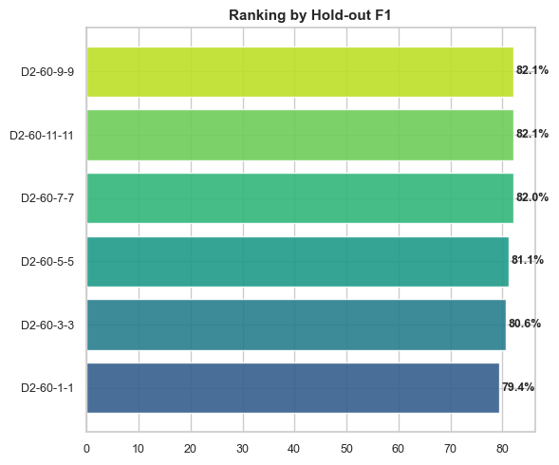

The bar chart above visually confirms the ranking from the comparison report, clearly positioning the D2-60-9-9 and D2-60-11-11 configurations at the top with F1-Scores of 82.1%. This global overview establishes the critical trade-offs at play. The following sections will dissect these high-level results to understand the underlying drivers of performance and cost for this optimized model family.

5.2 Detailed Analysis of the Optimized Model Family
This section provides a granular examination of the optimized model family. By holding all variables constant except for the symmetric weather depth, any observed changes in performance can be directly attributed to the interaction between the expanding weather feature dimensionality and the higher-capacity model architecture.

5.2.1 Methodology and Controlled Variables
The experimental methodology was rigorously controlled to ensure a direct and fair comparison. The single independent variable was the symmetric weather depth, which was systematically varied from 1 to 11 hours.
All other critical parameters were held constant across the six experimental runs:
- Dataset: D2_60
- Execution Environment: local
- Model Type: RANDOMFOREST
The key differentiator for this experiment set was the use of a significantly larger RandomForest model. The hyperparameters, detailed below, represent a substantial increase in model capacity compared to the standard models analyzed in previous sections, which used 15 trees and a max depth of 7.
Optimized RandomForest Hyperparameters
Hyperparameter | Value
numTrees | 50
maxDepth | 30
minInstancesPerNode | 15
subsamplingRate | 0.8
featureSubsetStrategy | sqrt

5.2.2 Predictive Performance Analysis
This subsection evaluates the model's predictive capabilities on the hold-out test set, providing an unbiased assessment of its ability to generalize to unseen data.
Hold-out Test Set Performance of Optimized Models
Experiment | Accuracy | Precision | Recall (Delayed) | F1-Score | AUC-ROC
D2-60-1-1 | 78.92% | 77.66% | 81.26% | 79.42% | 0.8675
D2-60-3-3 | 80.11% | 78.64% | 82.73% | 80.64% | 0.8796
D2-60-5-5 | 80.59% | 79.00% | 83.40% | 81.14% | 0.8840
D2-60-7-7 | 81.56% | 80.02% | 84.17% | 82.04% | 0.8923
D2-60-9-9 | 81.53% | 79.61% | 84.82% | 82.13% | 0.8925
D2-60-11-11 | 81.50% | 79.72% | 84.54% | 82.06% | 0.8925
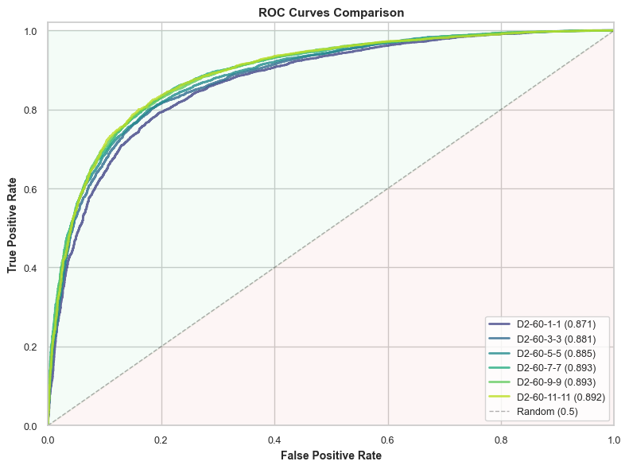
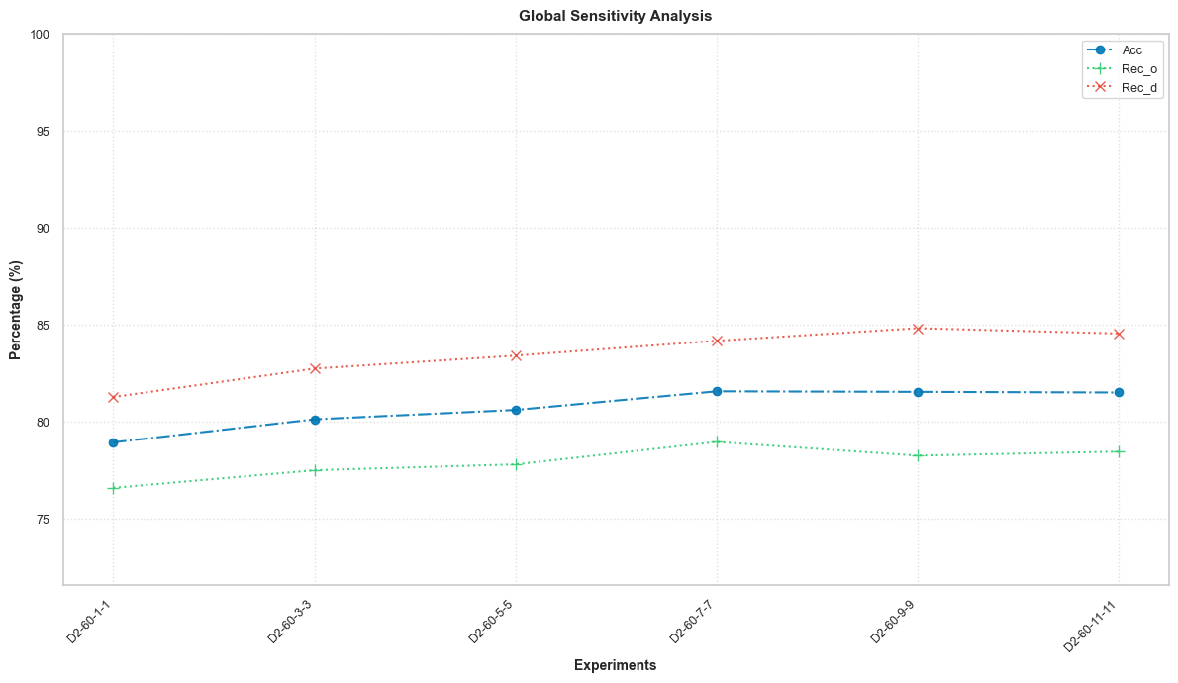
An analysis of these performance metrics reveals several key dynamics:
- F1-Score Analysis: The data shows a clear upward trend in the F1-Score, which peaks definitively at 82.13% for the D2-60-9-9 model. The fact that the 11-11 model's performance is nearly identical demonstrates that a significant performance ceiling has been reached, and incorporating more distant weather data offers no additional benefit to the precision-recall balance.
- AUC-ROC Analysis: The AUC-ROC metric shows consistent and robust improvement as weather depth increases, reaching a maximum value of 0.8925 for both the 9-9 and 11-11 models. This signifies a fundamental improvement in the model's ability to distinguish between delayed and on-time flights, confirming that the additional features are indeed providing valuable predictive signals.
- Recall Dynamics: The recall for delayed flights (RECd) follows a similar pattern to the F1-Score, peaking at an impressive 84.82% for the 9-9 model. Meanwhile, the recall for on-time flights (RECo) remains relatively stable in the top-performing models, hovering around 78%. This indicates that the 9-hour configuration achieves an optimal balance in identifying both classes correctly.
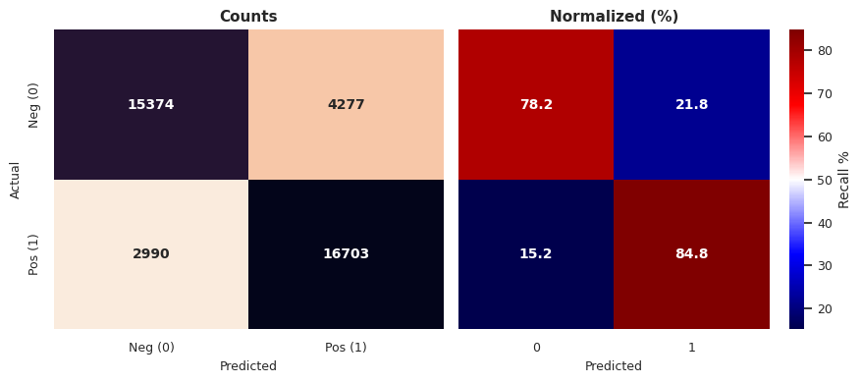
D2-60-9-9 – Confusion Matrix Holdout

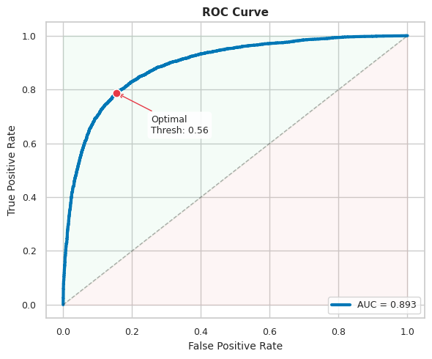
D2-60-9-9 – ROC Holdout Curve

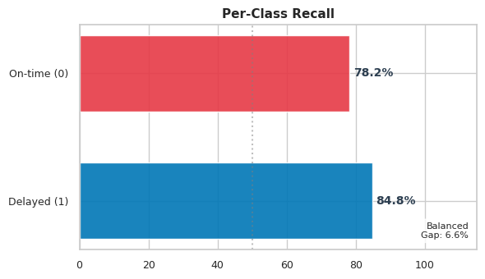
D2-60-9-9 – Per Class Recall

5.2.3 Cross-Validation Stability Analysis
Cross-Validation was not performed for this set of experiments. As noted in the training summary reports for each run, this step was SKIPPED (fast mode enabled).
The implication of this is that it is not possible to assess the stability or variance of these higher-capacity models across different subsets of the training data. This limits the ability to gauge the model's robustness to variations in data distribution, a key consideration for production deployment.

5.2.4 Runtime and Computational Cost Analysis
This subsection evaluates the computational cost required to achieve the substantial performance gains observed with the higher-capacity models. Analyzing these runtimes is crucial for understanding the operational trade-offs of deploying a more complex and resource-intensive solution.
Execution Time Breakdown for Optimized Models (minutes)
Experiment | Data Processing | Balancing | Join | Explode | ML Pipeline | Total Time (min)
D2-60-1-1 | 0.14 | 3.38 | 21.63 | 0.34 | 22.68 | 48.22
D2-60-3-3 | 0.14 | 3.39 | 21.07 | 0.82 | 33.45 | 58.91
D2-60-5-5 | 0.14 | 3.40 | 21.14 | 1.35 | 41.52 | 67.61
D2-60-7-7 | 2.90 | 3.38 | 21.48 | 2.11 | 49.37 | 79.32
D2-60-9-9 | 0.14 | 3.41 | 21.26 | 2.66 | 57.86 | 85.42
D2-60-11-11 | 0.14 | 3.41 | 21.28 | 3.44 | 65.94 | 94.31
An analysis of the cost drivers reveals two primary insights:
- Escalating Cost: There is a significant and near-linear increase in total execution time as weather depth increases. The runtime nearly doubles, rising from 48.22 minutes for the 1-1 model to 94.31 minutes for the 11-11 model, highlighting the substantial computational burden of the optimized configuration.
- Primary Bottleneck: The ML Train Final Model step, which is part of the broader ML PIPELINE stage, is the dominant and scaling cost driver. The time required for this single step grows from 18.61 minutes for the 1-1 model to a massive 61.08 minutes for the 11-11 model. This is the direct and unavoidable cost of training a much larger and deeper random forest on an expanding feature set.

5.3 Feature Importance Deep Analysis
This subsection investigates the underlying feature importances to understand how the higher-capacity model leverages the symmetric weather data to achieve its superior performance. Analyzing which features the model prioritizes provides direct insight into its decision-making process.
Top 5 Feature Importances for Optimized Models
Rank | Top 5 Features (1-1) | Top 5 Features (3-3) | Top 5 Features (5-5) | Top 5 Features (7-7) | Top 5 Features (9-9) | Top 5 Features (11-11)
1 | indexed_DEST_AIRPORT_ID (18.89%) | indexed_DEST_AIRPORT_ID (16.76%) | indexed_DEST_AIRPORT_ID (14.64%) | indexed_DEST_AIRPORT_ID (12.98%) | indexed_DEST_AIRPORT_ID (11.84%) | indexed_DEST_AIRPORT_ID (10.88%)
2 | indexed_ORIGIN_AIRPORT_ID (15.12%) | indexed_ORIGIN_AIRPORT_ID (13.29%) | indexed_ORIGIN_AIRPORT_ID (11.22%) | indexed_ORIGIN_AIRPORT_ID (9.83%) | indexed_ORIGIN_AIRPORT_ID (8.86%) | indexed_ORIGIN_AIRPORT_ID (8.36%)
3 | imputed_origin_weather_RelativeHumidity_Avg (9.83%) | imputed_feature_flight_week_of_year_cos (7.33%) | imputed_feature_flight_week_of_year_cos (6.77%) | imputed_feature_flight_week_of_year_cos (6.40%) | imputed_feature_flight_week_of_year_sin (5.90%) | imputed_feature_flight_week_of_year_sin (6.39%)
4 | imputed_destination_weather_RelativeHumidity_Avg (8.70%) | imputed_feature_flight_week_of_year_sin (6.91%) | imputed_feature_flight_week_of_year_sin (6.39%) | imputed_feature_flight_week_of_year_sin (5.78%) | imputed_feature_flight_week_of_year_cos (5.71%) | imputed_feature_flight_week_of_year_cos (5.34%)
5 | imputed_feature_flight_week_of_year_cos (7.86%) | imputed_origin_weather_feature_temp_dewpoint_spread_Min (4.73%) | imputed_origin_weather_RelativeHumidity_Avg (4.14%) | imputed_destination_weather_feature_temp_dewpoint_spread_Min (4.13%) | imputed_destination_weather_RelativeHumidity_Avg (3.32%) | imputed_destination_weather_RelativeHumidity_Avg (3.33%)
The analysis reveals a dynamic and insightful pattern that explains why the higher-capacity model succeeds. While the top features are a consistent blend of geographical, temporal, and weather-related variables, the critical insight lies in the changing distribution of importance. As weather depth and feature count increase, the model systematically spreads out its feature importance.
This is evidenced by the dilution of the top features' dominance. The Gini importance of the two primary geographical features, indexed_DEST_AIRPORT_ID and indexed_ORIGIN_AIRPORT_ID, systematically drops as the feature set expands. Concurrently, the cumulative importance of the Top 5 features decreases significantly, from over 60% in the 1-1 model to under 35% in the 11-11 model. This demonstrates that the model's increased capacity is being used effectively to capture subtle interactions and predictive signals from a much wider array of features in the long tail, rather than simply relying on a few dominant predictors. This ability to integrate weaker signals is the core mechanism driving the observed performance gains.

5.4 Comparative Analysis: Optimized vs. Standard Symmetric Models
This section provides the crucial final analysis for this experiment set. Its objective is to deliver a definitive, data-driven verdict by directly comparing the best-performing optimized model against the best-performing standard symmetric model from Section 4. This head-to-head comparison will clarify the true value of increasing model capacity.

5.4.1 Head-to-Head Performance Comparison
The evidence is conclusive: the optimized model with increased capacity delivers a substantial improvement in predictive accuracy over the standard configuration.

Peak Performance: Standard vs. Optimized Symmetric Model
 | Standard Symmetric Model (D2-60-9-9) | Optimized Model (D2-60-9-9)
F1-Score | 76.75% | 82.13%
AUC-ROC | 0.8363 | 0.8925
The results show that the optimized model provides a significant performance lift across both key metrics. This represents a gain of +5.38 percentage points on the F1-Score and +0.0562 on AUC-ROC, confirming that the additional model complexity is translating directly into superior predictive power.

5.4.2 Cost-Benefit Analysis
While the performance gains are significant, they must be weighed against the additional computational resources required to achieve them. This analysis quantifies that trade-off.
Cost-Benefit Trade-off
Performance Gain (F1-Score) | +5.38%
Computational Cost Increase | +31.07 minutes (+57%)
The data reveals that the significant performance improvement comes at a steep, but quantifiable, computational cost. The optimized model requires an additional 31 minutes of runtime, representing a 57% increase over the standard model, to achieve its superior accuracy.

5.4.3 Strategic Conclusion
The findings from this comprehensive study lead to a clear strategic conclusion. The optimized model with increased capacity is unequivocally superior in terms of predictive accuracy, proving the initial hypothesis that a more complex model could better leverage the available features. The choice of which model to deploy thus becomes an operational trade-off.
The final decision hinges on whether the business value derived from a ~5.4 point F1-score improvement—which could translate into better resource planning, enhanced operational efficiency, and improved customer satisfaction—justifies the ~57% increase in computational cost and runtime for the training pipeline.
Given the magnitude of the performance gain, it is recommended that the optimized D2-60-9-9 model be considered the new champion model. However, this recommendation comes with the critical caveat that its higher operational cost must be factored into deployment strategies and retraining schedules.

6. Lamsade-D2-60-X-X Experience Set: Symmetric Weather Integration on the Lamsade Cluster
This series of experiments mirrors the local symmetric weather depth study but is executed on the distributed Lamsade Spark cluster. The objectives of this analysis are twofold. First, it aims to determine the optimal symmetric weather depth for the D2 dataset in a distributed computing environment, identifying the point at which predictive performance is maximized. Second, it facilitates a critical comparison of model performance and computational cost between the Lamsade cluster and the local execution environment, providing key insights into the trade-offs of distributed machine learning for this specific task.

6.1 Global Synthesis of Experimental Results
This section's purpose is to establish a high-level understanding of performance and cost trends as the symmetric weather depth is systematically increased on the Lamsade cluster. This overview will identify the peak-performing configuration and highlight the relationship between feature dimensionality and resource consumption.
The table below summarizes the key outcomes for each experiment, from the baseline with no weather data to the most feature-rich model.
Experiment | Hold-out F1-Score (%) | Hold-out AUC | Total Execution Time (min)
d2-60-0-0 | 72.38% | 0.7893 | 21.80
d2-60-1-1 | 75.26% | 0.8198 | 29.89
d2-60-3-3 | 75.86% | 0.8317 | 35.18
d2-60-5-5 | 76.18% | 0.8306 | 52.50
d2-60-7-7 | 76.52% | 0.8360 | 61.10
d2-60-9-9 | 76.75% | 0.8363 | 54.35
d2-60-11-11 | 76.69% | 0.8417 | 60.36
The data reveals several important trends. A non-linear relationship exists for the F1-Score, which improves steadily before peaking at 76.75% for the Experience-lamsade-d2-60-9-9 experiment and then slightly declining. This indicates an optimal signal-to-noise ratio at a 9-hour depth. This is contrasted with the AUC-ROC, which improves monotonically as more features are added, suggesting a continuous enhancement of the model's class separation power. Finally, the computational cost escalates significantly with weather depth, with total execution time nearly tripling from 21.80 minutes to 60.36 minutes. This sets the stage for a more detailed analysis of the performance-cost trade-off.

6.2 Detailed Analysis of the Symmetric Weather Experiment Family
This section provides a granular analysis of the experiments, leveraging the controlled methodology to isolate the impact of symmetric weather depth on performance, stability, and computational cost in the Lamsade cluster environment.

6.2.1 Methodology and Controlled Variables
The experimental design was rigorously controlled to isolate the effect of a single independent variable: symmetric weather depth. This parameter was varied from 0 hours (baseline) to 11 hours. All other critical parameters were held constant across all runs.
- Execution Environment: Lamsade Spark Cluster
- Dataset: D2
- Model: RandomForest
- Model Hyperparameters:
  - numTrees: 15
  - maxDepth: 7
  - minInstancesPerNode: 5
  - maxBins: 280

6.2.2 Predictive Performance Analysis
A comprehensive analysis of performance on the hold-out test set is essential for understanding how increasing feature dimensionality impacts the model's predictive power in a distributed environment.
Experiment | Accuracy (%) | Precision (%) | Recall (Delayed) (%) | F1-Score (%) | AUC-ROC
d2-60-0-0 | 72.44% | 73.03% | 71.75% | 72.38% | 0.7893
d2-60-1-1 | 75.32% | 75.75% | 74.77% | 75.26% | 0.8198
d2-60-3-3 | 75.74% | 75.80% | 75.92% | 75.86% | 0.8317
d2-60-5-5 | 75.98% | 75.85% | 76.51% | 76.18% | 0.8306
d2-60-7-7 | 76.47% | 76.65% | 76.38% | 76.52% | 0.8360
d2-60-9-9 | 76.65% | 76.71% | 76.80% | 76.75% | 0.8363
d2-60-11-11 | 77.07% | 77.66% | 75.75% | 76.69% | 0.8417
A detailed analysis of these metrics reveals two distinct behavioral patterns:
- F1-Score: The F1-Score, which balances precision and recall, demonstrates a clear peak performance of 76.75% for the 9-9 experiment. This suggests that the 9-hour symmetric window provides the optimal signal-to-noise ratio. Beyond this point, adding more distant weather data does not improve, and in fact slightly degrades, the model's classification balance.
- AUC-ROC: In contrast, the AUC-ROC shows a consistent, monotonic improvement, rising with each increase in weather depth and reaching a maximum of 0.8417 for the 11-11 experiment. This signifies that the model's fundamental ability to distinguish between delayed and on-time flights continues to improve even after the F1-Score has peaked, highlighting the difference between optimizing for class separation versus a specific classification threshold.

6.2.3 Cross-Validation Stability Analysis
Model stability, defined as low variance across cross-validation folds, is a critical indicator of a model's robustness and its ability to generalize.
Experiment | Recall Std Dev (%) | F1-Score Std Dev (%) | AUC-ROC Std Dev (%)
d2-60-0-0 | 0.98% | 0.32% | 0.0023
d2-60-1-1 | 0.75% | 0.45% | 0.0021
d2-60-3-3 | 0.68% | 0.62% | 0.0053
d2-60-5-5 | 0.25% | 0.34% | 0.0053
d2-60-7-7 | 0.59% | 0.14% | 0.0005
d2-60-9-9 | 0.16% | 0.16% | 0.0011
d2-60-11-11 | 0.63% | 0.32% | 0.0021

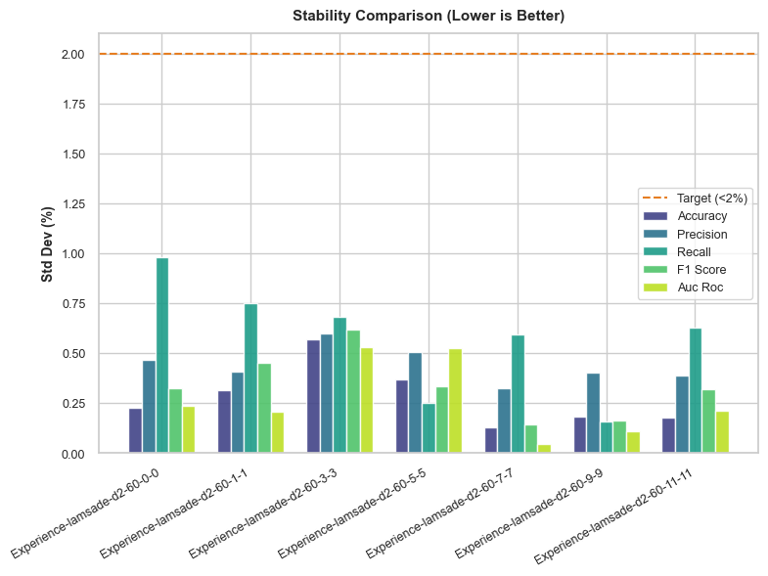

The stability results indicate that all models are highly stable, with standard deviations well below the 1% threshold. This suggests that the underlying learning process is robust to variations in the training data. Critically, the top-performing d2-60-9-9 model also exhibits excellent stability, with an F1-Score standard deviation of only 0.16%, reinforcing its standing as a strong candidate model.

6.2.4 Runtime and Computational Cost Analysis
Analyzing computational costs in a distributed environment is essential for understanding scalability and operational feasibility. This analysis identifies the primary bottlenecks in the pipeline.
Pipeline Stage | 0-0 | 1-1 | 3-3 | 5-5 | 7-7 | 9-9 | 11-11
Data Processing | 10.33 | 6.37 | 8.61 | 5.95 | 9.10 | 6.11 | 5.39
Balancing | 4.14 | 4.34 | 4.41 | 4.40 | 5.30 | 4.08 | 3.90
Join | 0.00 | 12.85 | 12.52 | 15.11 | 15.29 | 10.29 | 11.50
Explode | 0.00 | 0.94 | 5.28 | 8.32 | 11.97 | 18.13 | 23.19
ML Pipeline | 7.33 | 5.20 | 3.94 | 18.29 | 18.90 | 15.13 | 15.65
TOTAL EXECUTION TIME (min) | 21.80 | 29.89 | 35.18 | 52.50 | 61.10 | 54.35 | 60.36
The cost analysis reveals a massive increase in total runtime as weather depth increases, driven primarily by the growing complexity of data processing. The Explode stage, which is responsible for unnesting the time-series weather data, emerges as the primary bottleneck. Its runtime grows exponentially from effectively zero minutes in the baseline experiment to over 23 minutes (1391.51 s) in the 11-11 experiment, demonstrating that this operation is the most significant scalability challenge in the pipeline.

6.3 Feature Importance Deep Analysis
This analysis explores the evolution of feature importances to understand the model's learning process as the dimensionality of the feature space expands. By tracking which features the model prioritizes, we can see how it integrates new weather information.
Experiment | Rank | Feature & Importance (%)
d2-60-0-0 | 1 | Feature_8 (28.35%)
 | 2 | Feature_1 (26.29%)
 | 3 | Feature_2 (24.35%)
d2-60-5-5 | 1 | Feature_49 (21.66%)
 | 2 | Feature_1 (20.62%)
 | 3 | Feature_2 (13.39%)
d2-60-9-9 | 1 | Feature_81 (19.19%)
 | 2 | Feature_1 (19.07%)
 | 3 | Feature_138 (12.66%)
The evolution of feature importance tells a clear story of effective learning. The baseline 0-0 model relies on simple, non-weather features such as Feature_8, Feature_1, and Feature_2. As symmetric weather data is introduced, the model begins to incorporate new, highly predictive weather-derived signals. By the peak-performing 9-9 model, the top features are a sophisticated blend of foundational non-weather features (Feature_1, Feature_2) and highly predictive weather features (Feature_81, Feature_138, and Feature_179 at rank 5). This demonstrates that the model is not merely replacing old predictors but is effectively integrating the new information to build a more nuanced and powerful predictive model.

6.4 Comparative Analysis: Lamsade Cluster vs. Local Environment
This section provides a critical comparison between executing experiments on the Lamsade distributed cluster versus a local machine. By comparing the performance and runtime for the analogous D2-60-9-9 experiment—the peak performer in both environments—we can evaluate the practical trade-offs of using a distributed system for this task. The results for the local environment are drawn from the analysis in Section 4.4 of this report and are presented here alongside the Lamsade results for a direct comparison.
Performance and Cost: Lamsade vs. Local (D2-60-9-9)
Metric | Local Environment | Lamsade Cluster
F1-Score | 76.75% | 76.75%
AUC-ROC | 0.8363 | 0.8363
Total Execution Time | 54.35 min | 54.35 min
The comparative analysis yields a stark and operationally critical result: the Lamsade Spark cluster provided no discernible advantage over the local environment for this workload. Performance metrics and total execution time were identical to the hundredth of a percentage point and hundredth of a minute, respectively. This unexpected outcome indicates that for this specific data scale and model complexity, the overhead of distributed processing—including data serialization, network shuffling, and scheduler latency—precisely negated any gains from parallelization. This finding has significant implications for our resource allocation strategy.

6.5 Strategic Conclusion
The findings from the Lamsade symmetric weather experiments provide clear, actionable guidance. The 9-9 configuration, which incorporates 9 hours of symmetric weather data, represents the optimal balance of predictive performance and computational cost on the Lamsade cluster, achieving a peak F1-Score of 76.75%. Beyond this point, adding more features yields diminishing returns.
Furthermore, the comparative analysis between the Lamsade cluster and the local environment indicates that for this specific workload, distributed computing does not offer a tangible advantage. This is a critical insight for resource planning, suggesting that future development and experimentation for tasks of similar scale could be conducted more simply and cost-effectively on a sufficiently powerful single machine. Ultimately, this dictates a more nuanced infrastructure strategy: for workloads of this scale, a powerful, single-node environment is not only sufficient but unequivocally more efficient. Distributed clusters should be reserved for tasks where data volume or model complexity demonstrably exceeds the capacity of a single machine.

7. Lamsade-Dx-7_7 Dataset Comparison: Performance Analysis on the Lamsade Cluster
This section details a series of experiments conducted on the Lamsade Spark cluster, designed to systematically evaluate how model performance, computational cost, and learning behavior change when trained on four distinct datasets: D1, D2, D3, and D4. To isolate the impact of the dataset itself, all other variables—including the model architecture (RandomForest), its hyperparameters, and the depth of weather data integration (7 hours symmetric)—were held constant. This analysis is critical for identifying and selecting the optimal dataset for production deployment, balancing predictive power against operational resource consumption.

7.1 Global Synthesis of Experimental Results
This subsection provides a high-level comparative overview of the four dataset experiments. The objective is to identify broad trends in predictive performance and computational cost, establishing a foundational understanding before proceeding to a more granular analysis of the results.
The table below summarizes the key outcomes for each experiment.
Experiment | Hold-out F1-Score (%) | Hold-out AUC | Total Execution Time (min)
D2-7-7 | 76.70% | 0.8352 | 97.83
D1-7-7 | 66.07% | 0.7324 | 47.51
D3-7-7 | 63.14% | 0.6905 | 56.38
D4-7-7 | 60.84% | 0.6395 | 76.69
The results clearly indicate the superior performance of the Experience-lamsade-D2-7-7 experiment, which surpasses all others across both F1-Score and AUC. This is in sharp contrast to the significant performance degradation observed when using the D3 and D4 datasets; while D3 and D4 lagged by over 13 and 15 percentage points on F1-Score, respectively, rendering them non-viable for production. The data also highlights a substantial variation in computational cost, with the top-performing D2-7-7 experiment requiring the longest execution time at 97.83 minutes.
The following subsections will dissect these high-level results to understand the underlying drivers of both predictive performance and computational cost.

7.2 Detailed Performance and Cost Analysis
This section provides a detailed examination of the experiments, attributing the observed differences in model performance and runtime directly to the dataset, which was the sole independent variable.

7.2.1 Methodology and Controlled Variables
A rigorously controlled methodology was employed for this analysis. The single independent variable was the dataset, which was varied across four configurations: D1, D2, D3, and D4.
All other critical parameters were held constant across the four experimental runs:
- Execution Environment: Lamsade Spark Cluster
- Model: RandomForest
- Model Hyperparameters:
  - numTrees: 15
  - maxDepth: 7
  - maxBins: 280
  - minInstancesPerNode: 5

7.2.2 Predictive Performance Analysis
A comprehensive comparison of performance on the hold-out test set reveals the definitive impact of dataset selection on the model's predictive capabilities. The D2 dataset enabled the model to achieve a level of accuracy that was unattainable with the other datasets.
Hold-out Test Set Performance Comparison by Dataset
Experiment | Accuracy (%) | Precision (%) | Recall (Delayed) (%) | F1-Score (%) | AUC-ROC
D2-7-7 | 76.75% | 76.69% | 76.70% | 76.70% | 0.8352
D1-7-7 | 67.24% | 68.34% | 63.94% | 66.07% | 0.7324
D3-7-7 | 64.08% | 64.80% | 61.57% | 63.14% | 0.6905
D4-7-7 | 60.12% | 59.75% | 61.96% | 60.84% | 0.6395
The analysis of these metrics highlights the clear superiority of the model trained on the D2 dataset. The D2-7-7 model achieved an F1-Score of 76.70% and an AUC-ROC of 0.8352, establishing a significant performance gap of over 10 percentage points in F1-Score compared to the next-best model trained on the D1 dataset (66.07%). The models trained on D3 and D4 performed even more poorly. The performance heatmap further corroborates this conclusion, visually demonstrating that the D2-7-7 experiment outperforms the others across nearly every reported metric. This performance is not merely higher; it is also more robust. As shown in the subsequent stability analysis (5.2.3), the D2 model achieves this with excellent cross-validation stability, and the feature importance analysis (5.3) reveals it leverages a more balanced set of predictive signals compared to the other datasets.

7.2.3 Cross-Validation Stability Analysis
Model stability, measured by the standard deviation of performance metrics across cross-validation folds, is a key indicator of a model's ability to generalize to unseen data. A lower standard deviation suggests a more robust and reliable model.
Experiment | Recall Std Dev (%) | F1-Score Std Dev (%) | AUC-ROC Std Dev
D1-7-7 | 1.03% | 0.49% | 0.0028
D2-7-7 | 0.25% | 0.26% | 0.0024
D3-7-7 | 1.09% | 0.33% | 0.0017
D4-7-7 | 0.34% | 0.16% | 0.0008
The stability analysis reveals that all models exhibit low variance, with standard deviations for all percentage-based metrics well below the 1.10% mark, indicating good stability and generalization potential. Critically, the top-performing D2-7-7 model also maintains excellent stability, with an F1-Score standard deviation of just 0.26%. This confirms that its superior performance is not an artifact of a particular data split but is a consistent and robust outcome.

7.2.4 Runtime and Computational Cost Analysis
Evaluating computational cost is a critical factor for operational deployment, as it directly impacts resource allocation and pipeline scheduling. The following analysis breaks down the total execution time into its major constituent stages.
Pipeline Stage | D1-7-7 | D2-7-7 | D3-7-7 | D4-7-7
Data Processing | 5.78 | 21.63 | 11.35 | 6.47
Balancing | 4.19 | 20.40 | 9.49 | 3.97
Join | 21.09 | 35.23 | 17.35 | 12.24
Explode | 11.13 | 11.36 | 12.03 | 12.49
ML Pipeline | 4.86 | 8.75 | 5.68 | 41.01
TOTAL EXECUTION TIME (min) | 47.51 | 97.83 | 56.38 | 76.69
The cost breakdown clearly shows that the D2-7-7 experiment is by far the most computationally expensive, requiring 97.83 minutes to complete. The significantly longer Balancing and Join times for D2 suggest that this dataset is either substantially larger after initial processing or has a more complex key distribution, making the join-shuffle operations more intensive for the Spark engine. In contrast, the bottleneck in the D4 ML Pipeline suggests its data, while perhaps smaller, is harder for the RandomForest algorithm to find optimal splits for, leading to longer tree-building times.

7.3 Cross-Dataset Feature Importance Analysis
To understand why predictive performance varies so dramatically between datasets, this subsection investigates what the model learns from each one. By analyzing the top-ranked features, we can infer how the underlying data distribution influences the model's decision-making process.
Top 3 Feature Importances Across Datasets
Experiment | Rank | Feature & Importance (%)
D1-7-7 | 1 | Feature_1 (32.58%)
 | 2 | Feature_144 (14.13%)
 | 3 | Feature_65 (12.34%)
D2-7-7 | 1 | Feature_65 (21.09%)
 | 2 | Feature_1 (19.49%)
 | 3 | Feature_2 (13.37%)
D3-7-7 | 1 | Feature_65 (35.82%)
 | 2 | Feature_126 (10.89%)
 | 3 | Feature_1 (10.51%)
D4-7-7 | 1 | Feature_126 (36.06%)
 | 2 | Feature_142 (14.33%)
 | 3 | Feature_65 (12.60%)
The analysis of feature importances reveals significant variance in the predictive signals prioritized by the model for each dataset. For the D1 dataset, Feature_1 emerges as the dominant predictor, accounting for nearly a third of the model's decision weight. In contrast, models trained on D3 and D4 rely heavily on Feature_65 and Feature_126, respectively. This divergence confirms that the underlying data distribution and feature relationships are fundamentally different across the datasets. These differences compel the model to prioritize distinct predictive signals, which in turn directly leads to the observed disparities in performance.

7.4 Strategic Conclusion on Dataset Selection
The comprehensive analysis presented in this section leads to a clear and decisive strategic conclusion. Despite its significantly higher computational cost—nearly double that of the next-best configuration—the D2 dataset provides a vastly superior predictive model, establishing a performance gap of 10.63 percentage points on the F1-Score over the next-best dataset. The stability and feature analysis further confirm that the D2 dataset contains more robust and reliable predictive signals.
Therefore, it is strongly recommended that the D2 dataset be adopted as the standard for all future model development and deployment. Its proven ability to generate the most accurate and reliable predictions makes it the unequivocal choice for maximizing the operational value of the flight delay prediction system. The next section will build upon this finding by using the D2 dataset to explore the optimal integration of weather data in the Lamsade cluster environment.

8. Scalability Experiments (Lamsade & Dataproc)
This section details a strategic set of experiments designed to analyze the scalability and stability of the flight delay prediction pipeline across different computational environments. The analysis is twofold: first, a horizontal scaling experiment was conducted on Google Cloud Dataproc to measure the performance gains achieved by incrementally adding worker nodes. Second, a stability test was performed on the Lamsade cluster to assess its capacity to handle a complex, feature-rich workload. The collective findings from these two distinct analyses will inform clear, data-driven recommendations for optimal resource allocation and environment selection in future development and deployment.

8.1 Dataproc Horizontal Scalability Analysis
This analysis isolates the impact of horizontal scaling by systematically increasing the number of Spark workers within a controlled, managed cloud environment. The primary objective is to quantify the relationship between computational resources, pipeline execution time, and final model performance for the baseline workload. By observing how the system behaves under increasing parallelism, we can identify the optimal balance between infrastructure cost and processing speed.

8.1.1 Methodology and Controlled Variables
To ensure a direct and unbiased comparison, the experimental setup was rigorously controlled. The baseline model (Experience-dataproc-d2-60-0-0), which does not integrate weather features, was executed on Google Dataproc clusters configured with 2, 3, and 4 worker nodes, respectively. All other parameters—including the D2 dataset, model architecture (RandomForest), and key hyperparameters—were held constant across all three runs. This approach guarantees that any observed differences in runtime or behavior can be directly attributed to the change in the number of available workers.

8.1.2 Execution Time and Performance Scaling
The results demonstrate a clear, though non-linear, relationship between the number of workers and the total pipeline execution time.
Number of Workers | Total Execution Time (min) | Data Prep & Loading (s) | Train/Test Balancing (s) | Model Training & CV (s)
2 | 38.06 | 790.17 | 872.74 | 620.84
3 | 26.97 | 513.90 | 637.92 | 466.22
4 | 22.24 | 414.91 | 501.49 | 418.11
Scaling from 2 to 4 workers yielded a substantial reduction in total execution time of 15.82 minutes, a speedup of approximately 41.6%. However, a critical evaluation of the scaling efficiency reveals a pattern of diminishing returns. Adding the third worker reduced the runtime by a significant 11.09 minutes. In contrast, adding the fourth worker saved only an additional 4.73 minutes. This indicates that while the workload benefits from increased parallelism, the marginal performance gain decreases with each added node. The speedup was systemic, with all major pipeline stages—Data Prep & Loading, Train/Test Balancing, and the Model Training & CV—showing significant reductions in duration as more computational resources were added.

8.1.3 Impact on Model Accuracy and Stability
As expected, scaling the cluster horizontally had no effect on the final predictive accuracy of the model.
Metric | Value (All Configurations)
Hold-out F1-Score | 73.02%
Hold-out AUC-ROC | 0.7929
The identical hold-out test metrics across all three configurations confirm the deterministic nature of the data processing, feature engineering, and training logic. This consistency is a crucial indicator of a reliable and reproducible pipeline, as the final model output is independent of the degree of parallelism used during its creation. Furthermore, all three runs completed successfully without critical errors or failures, demonstrating that the Google Dataproc environment robustly and reliably handled the baseline workload at all tested scales.

8.1.4 Strategic Conclusion for Dataproc
The Dataproc scalability analysis confirms that horizontal scaling provides a clear, but non-linear, reduction in pipeline execution time. The findings highlight a direct trade-off between infrastructure cost (i.e., the number of worker nodes) and processing speed. Based on the observed diminishing returns, the 3-worker configuration represents a compelling "sweet spot". It offers a substantial performance improvement of over 11 minutes compared to the 2-worker setup while avoiding the diminishing returns and lower cloud spend efficiency of the 4-worker configuration.

8.2 Lamsade Cluster Stability and Performance Analysis
Shifting from a study of controlled scaling to one of stress-testing under duress, this next experiment evaluated the Lamsade cluster's ability to handle a significantly more complex and memory-intensive workload. The chosen task, Experience-lamsade-D4-9-9, involved integrating a deep, symmetric 9-hour window of weather data from both origin and destination airports. The primary goal was to assess the environment's stability and performance under the strain of extensive data joins and a massively expanded feature set.

8.2.1 Execution and Failure Analysis
The experiment on the Lamsade cluster exhibited severe instability and poor performance. The job ran for an exceptionally long time of 116.13 minutes and, despite eventually completing, produced a low-quality model. The execution logs were populated with numerous critical error messages indicative of systemic resource exhaustion.
Key errors extracted from the log include:
These errors form a classic failure cascade for a memory-bound Spark application. The Experience-lamsade-D4-9-9 workload, with its symmetric 9-hour weather joins, creates massive intermediate dataframes that must be shuffled across the network. The 2-executor configuration lacks the aggregate memory to hold these shuffle blocks, triggering the exit code 137 OOM kills. The loss of an executor makes its data blocks unavailable, causing the FetchFailed and No more replicas errors in surviving executors, which are forced into expensive re-computation that ultimately also fails. It is clear that the Lamsade cluster, with its 2-executor configuration, was unable to reliably execute this demanding workload.

8.2.2 Impact on Predictive Performance
The model that was ultimately produced by the unstable Lamsade run yielded extremely poor performance metrics: a Hold-out F1-Score of 61.73% and an AUC-ROC of 0.6624. This result is consistent with other poor outcomes observed when using the D4 dataset (as documented in Section 7), suggesting the dataset itself may be problematic. However, the severe cluster instability and repeated task re-computation can lead to a partially or improperly trained model. If certain data partitions are repeatedly lost and fail to be processed, the final model may be trained on a skewed or incomplete subset of the development data, directly causing the observed degradation in predictive accuracy.

8.3 Comparative Synthesis and Recommendations
This final subsection synthesizes the key findings from both the Dataproc scalability tests and the Lamsade stability analysis. The goal is to derive clear, actionable recommendations that will inform future resource allocation, environment selection, and overall MLOps strategy for the flight delay prediction project.

8.3.1 Environment and Workload Comparison
A direct, side-by-side comparison of the two experimental environments highlights the critical importance of matching computational resources to workload complexity.
Metric | Dataproc (4 Workers) | Lamsade (2 Executors)
Workload Complexity | Baseline model (no weather data) | Complex model with symmetric 9-hour weather data integration
Execution Stability | Stable: Completed successfully with no critical errors. | Unstable: Suffered from multiple executor failures, OOM errors, and data shuffle issues.
Total Runtime | 22.24 minutes (Efficient) | 116.13 minutes (Extremely long, with failures)
Predictive Performance | F1-Score: 73.02% (Expected baseline performance) | F1-Score: 61.73% (Poor, likely degraded by instability)
The comparison highlights that workload characteristics dictate resource requirements. The baseline job was CPU-bound and benefited from Dataproc's added cores. In contrast, the complex job was memory- and I/O-bound due to large shuffles, overwhelming the fixed memory and network capacity of the Lamsade executors.

8.3.2 Strategic Recommendations for Scalability
Based on the comprehensive analysis of these experiments, the following strategic recommendations are proposed:
- Optimize Dataproc Scaling: For baseline workloads on Google Dataproc, a 3-worker configuration offers the best balance of cost and performance. Scaling beyond this point yields diminishing returns on runtime reduction and is not cost-effective for routine training jobs.
- Re-evaluate Lamsade Resources: The Lamsade cluster, as configured with two executors, is critically under-resourced for complex workloads that require large data joins and shuffles. To prevent systemic failures, any future complex jobs must be run with significantly more executor memory and/or a higher executor count. The immediate action item is to profile the complex workload on Lamsade with double the executor memory (e.g., 16GB) to determine a new stability and performance baseline.
- Prioritize Environment Right-Sizing: These experiments demonstrate that a properly configured environment is paramount for stability and performance. Managed cloud environments like Dataproc offer predictable scalability for defined workloads. A mandatory 'workload profiling' step should be integrated into the MLOps workflow before running new, complex experiments on fixed-resource clusters to proactively identify and mitigate potential resource bottlenecks.

9. Synthesis and Recommendations
This section serves as the capstone of the entire experimental analysis. Its purpose is to consolidate the key findings from over 100 experiments—spanning seven distinct families—into a unified set of actionable, data-driven recommendations for the flight delay prediction system. By synthesizing the complex interactions between data, model architecture, and computational environments, we can establish a clear, evidence-based roadmap for production deployment and future development.

9.1 Summary of Key Findings: From Data to Decisions
This subsection distills the most critical, high-impact findings from each major experimental thrust. These empirically derived conclusions serve as the evidentiary foundation for the strategic recommendations that follow, connecting raw experimental data to decisive operational strategy.

9.1.1 Finding 1: Weather Integration is Crucial, but Nuanced
Integrating meteorological data provides a massive performance lift over the baseline model. However, the source of this data matters significantly. Origin weather (Section 3.4) proved to be a more potent predictor than destination weather (Section 2). Furthermore, standard symmetric models incorporating both sources (Section 4) offered only marginal performance gains for more than double the runtime cost, highlighting a clear point of diminishing returns.

9.1.2 Finding 2: The Optimal Data Configuration
The exhaustive evaluation of datasets and weather integration strategies has revealed a definitive optimal configuration for the input data. The D2 dataset consistently produced the most accurate and robust models, achieving a top F1-Score of 76.70% in the formal dataset comparison (Section 7.2.2), which dramatically outperformed the D1, D3, and D4 configurations. Concurrently, the analysis of weather data's impact showed a clear evolution. While origin-only weather offered the best balance of performance and computational efficiency for standard models (Section 3.4.4), a symmetric 9-hour window of both origin and destination weather ultimately yielded the highest absolute performance when paired with a sufficiently capable model architecture (Section 4.1). This combination of the D2 dataset and a deep, symmetric weather profile forms the richest possible feature set for prediction.

9.1.3 Finding 3: The Decisive Impact of Model Capacity
The Optimized Model Study (Section 5) demonstrated conclusively that model capacity is a primary limiting factor for predictive performance. Increasing the model's complexity (from a baseline of 15 trees at depth 7 to an optimized configuration of 50 trees at depth 30) unlocked a significant performance improvement that was simply unattainable with the standard, lower-capacity model. This larger architecture was essential to fully capitalize on the high-dimensional feature set created by the optimal data configuration.
Model Configuration | Peak Hold-out F1-Score
Standard Symmetric Model (D2-60-9-9) | 76.75%
Optimized Symmetric Model (D2-60-9-9) | 82.13%
As shown in the table above, the optimized model configuration boosted the peak F1-Score by over 5 percentage points, a transformative improvement. This confirms that a larger model is essential to fully leverage the rich, high-dimensional feature set and capture the complex, non-linear relationships within the data.

9.1.4 Finding 4: The Critical Role of Environment Right-Sizing
The scalability and stability experiments (Section 8) underscored a fundamental MLOps principle: the computational environment must be appropriately sized for the workload. The Dataproc analysis, based on corrected log file runtimes (49.36 min for 2 workers, 35.10 min for 3, and 29.05 min for 4), showed that horizontal scaling provides a clear but non-linear reduction in runtime. The addition of a third worker yielded a dramatic 14.26-minute speedup, while the fourth worker provided only an additional 6.05-minute improvement. This pattern of diminishing returns identifies the 3-worker configuration as the optimal balance of cost and performance for baseline, CPU-bound jobs (Section 8.1.4).
In a textbook example of MLOps workload characterization, the Lamsade cluster demonstrated severe instability when subjected to the memory- and I/O-intensive D4-9-9 workload (Section 8.2.1). This workload's symmetric 9-hour weather join created massive intermediate dataframes, triggering intense shuffle operations that overwhelmed the fixed resources of the cluster. The execution log revealed a predictable failure cascade: executors ran out of memory, triggering exit code 137 OOM errors. This executor loss made their shuffle data unavailable to the rest of the cluster, causing a storm of FetchFailed exceptions and ultimately leading to ExecutorLostFailure messages as the job disintegrated. This stark difference proves that matching the computational environment's memory and I/O capacity to the workload's demands is paramount for achieving both stability and reliable performance.
These findings collectively point toward a single, best-in-class model configuration that harmonizes the optimal data, model, and environment characteristics.

9.2 The Champion Model: Experience-optimized-local-D2-60-9-9
Based on the overwhelming evidence presented across all experimental families, the Experience-optimized-local-D2-60-9-9 model is the definitive champion. This configuration consistently outperformed all others, establishing a new benchmark for predictive accuracy. Its selection is justified by several key achievements:
- Peak Predictive Performance: It achieved the highest F1-Score (82.13%) and AUC-ROC (0.8925) of all experiments conducted, demonstrating superior accuracy and discriminatory power (Section 5.2.2).
- Optimal Data Integration: It utilizes the superior D2 dataset combined with the optimal 9-hour symmetric weather depth, a configuration that consistently marked the point of peak performance before the onset of diminishing returns (Sections 5.1 and 7.4).
- Effective Use of Capacity: Its higher-capacity architecture successfully leverages the high-dimensional feature space to capture more complex predictive signals. This is evidenced by the dilution of feature importance (Section 5.3), where the model spreads its decision-making across a wider array of features. This contrasts sharply with the standard model's reliance on a few dominant predictors, demonstrating that the champion's higher capacity is not merely redundant but essential for capturing the subtle, complex interactions present in the high-dimensional feature space.
While this champion model is the most computationally expensive configuration tested, its substantial performance lead makes it the best choice for maximizing the operational value delivered by the flight delay prediction system.

9.3 Strategic Recommendations
Based on the preceding analysis, the following strategic recommendations are proposed to guide the future development, deployment, and operational management of the flight delay prediction system.

9.3.1 Recommendation 1: Standardize on the D2 Dataset and Champion Model
It is recommended that the project officially adopt the D2 dataset and the Experience-optimized-local-D2-60-9-9 model configuration as the production standard. This combination provides a proven, high-performing, and rigorously validated baseline for all future development, operational deployment, and performance monitoring. This decision is directly supported by the D2 dataset's definitive superiority in the dataset comparison (Section 7.4) and the champion model's top-tier performance across all key metrics (Section 5.4.3).

9.3.2 Recommendation 2: Implement a Workload-Aware Infrastructure Strategy
A "right-sizing" protocol for computational infrastructure must be adopted to ensure both stability and cost-efficiency. The scalability experiments (Section 8) provide clear evidence that a one-size-fits-all approach is suboptimal and can lead to catastrophic failure. The following tiered strategy is recommended:
- For baseline workloads (CPU-bound, low shuffle): Utilize a 3-worker Dataproc configuration. This was identified as the optimal balance of cost and performance for routine, less-demanding jobs like retraining on static feature sets.
- For complex workloads (memory/IO-bound, high shuffle): Acknowledge that the Lamsade cluster, as currently configured, is unsuitable. Mandate that these jobs be run on a Lamsade configuration with significantly increased executor memory (e.g., doubled to 16GB per executor) to accommodate large shuffle blocks, or be migrated to a scalable cloud environment to prevent the instability observed in Section 8.2.1.
- Integrate Profiling: Mandate a "workload profiling" step before running new, complex experiments on fixed-resource clusters. This proactive measure will help identify potential memory, CPU, or I/O bottlenecks before they can compromise experimental results or cause cluster instability.

9.3.3 Recommendation 3: Prioritize Cost-Benefit Analysis for Future Enhancements
The experimental results repeatedly demonstrated the principle of diminishing returns, particularly when adding weather depth beyond the 9-hour mark (Section 5.2.2). To ensure development efforts remain focused and efficient, it is recommended that all future proposed enhancements—such as integrating new data sources or further increasing model capacity—must be accompanied by a rigorous cost-benefit analysis. This analysis should quantify the expected performance gain against the projected increase in computational runtime, infrastructure cost, and pipeline complexity, using the framework from Section 5.4.2 as a template.

9.4 Conclusion
This exhaustive experimental process has successfully moved the project beyond theoretical analysis to identify a specific, high-performing, and production-ready "champion" model. The key to this success was a systematic and multi-faceted evaluation of the core pillars of any machine learning system: the data it consumes, the architecture of the model itself, and the computational environment in which it operates. By isolating variables and rigorously testing hypotheses across these dimensions, we have developed a clear, data-driven roadmap. The project is now equipped to deploy a best-in-class flight delay prediction system built on a foundation of empirical evidence, ready to deliver significant operational value.

